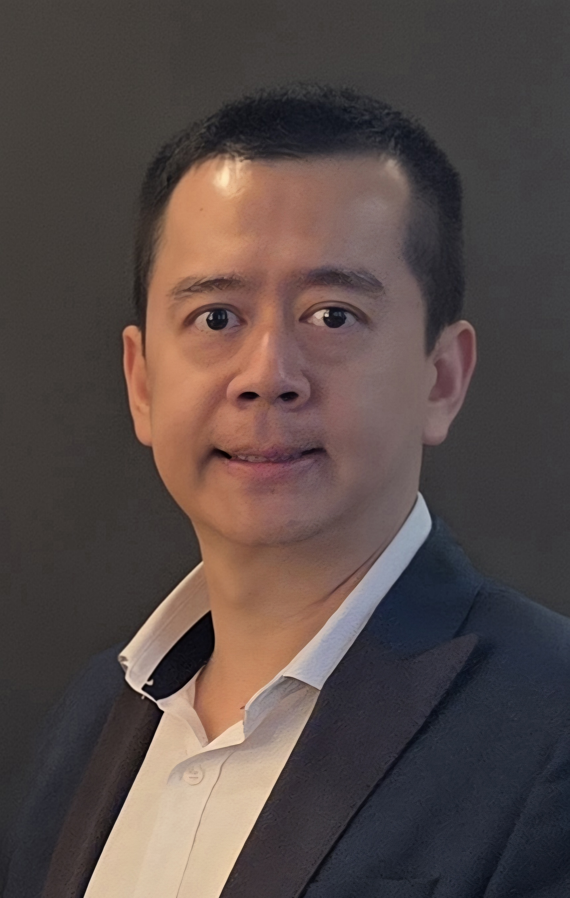

SK Tiong
Beech Tree Medical Practice, Rugby
Aspiring Leader Fellow 2025/26 - Cohort 6

I am a GP Partner at Beech Tree Medical Practice in Rugby, where I lead on finance, operations, and service development. I’ve introduced in-practice minor surgery and musculoskeletal services to improve patient access, and helped our practice gain accreditation as a GP training site. I supervise medical students, FY2 doctors, and GP registrars, and I am passionate about developing a resilient, well-supported primary care workforce.
As the only Chinese GP in Rugby, I’ve become a trusted point of care for the growing Chinese and Hong Kong migrant community. This experience has strengthened my commitment to improving access, tackling health inequalities, and designing culturally responsive services.
I was drawn to the Aspiring Leaders Fellowship to grow my system leadership skills and contribute more widely to inclusive service innovation. I look forward to collaborating with others working in health equity, digital access, or workforce transformation across Coventry and Warwickshire.

