Dr Sarah Raistrick

Trailblazer Fellow 2023-24
Coventry & Warwickshire Cohort 4

I started this fellowship in a privileged position, as a mid-career GP, already connected to much health inequalities work and rooted in the community that I've worked in for 10 years

Starting the fellowship was something we did as a practice at Willenhall Primary Care Centre with me as nominated Fellow. Our aim was to raise the profile of health inequalities work amongst the wider practice, to improve our thinking on the issues and to tangibly reduce inequalities in access, experience and outcomes.
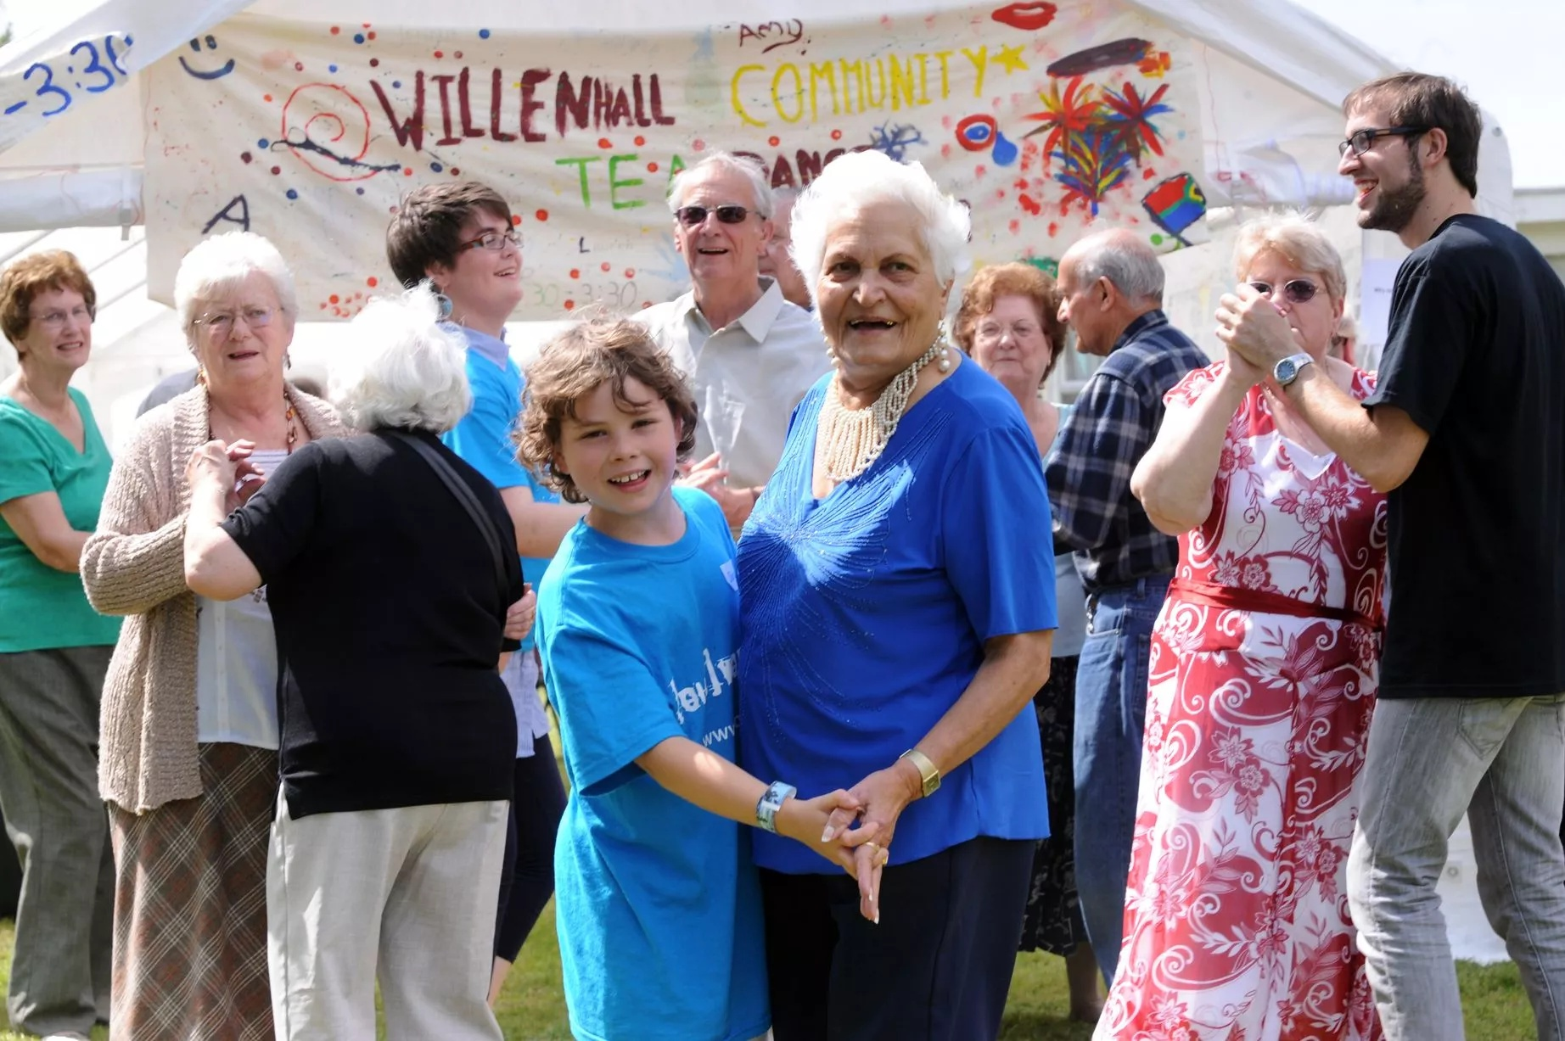
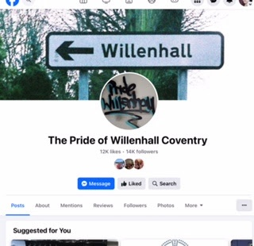

We felt important to focus on something tangible and local using a population health management (PHM). We used local and practice data as well as brainstorming with staff and patients ensuring we had a community centred approach even to a "medical model".

Inspired by:

- Priority Wards by Bentlely/Britain, "impact can be made in real time and the community voice and understanding of causes of causes is key.

- And using practice data, Core 20Plus5 priorities and community voice under-treated hypertension and high rates of cardiac death was chosen

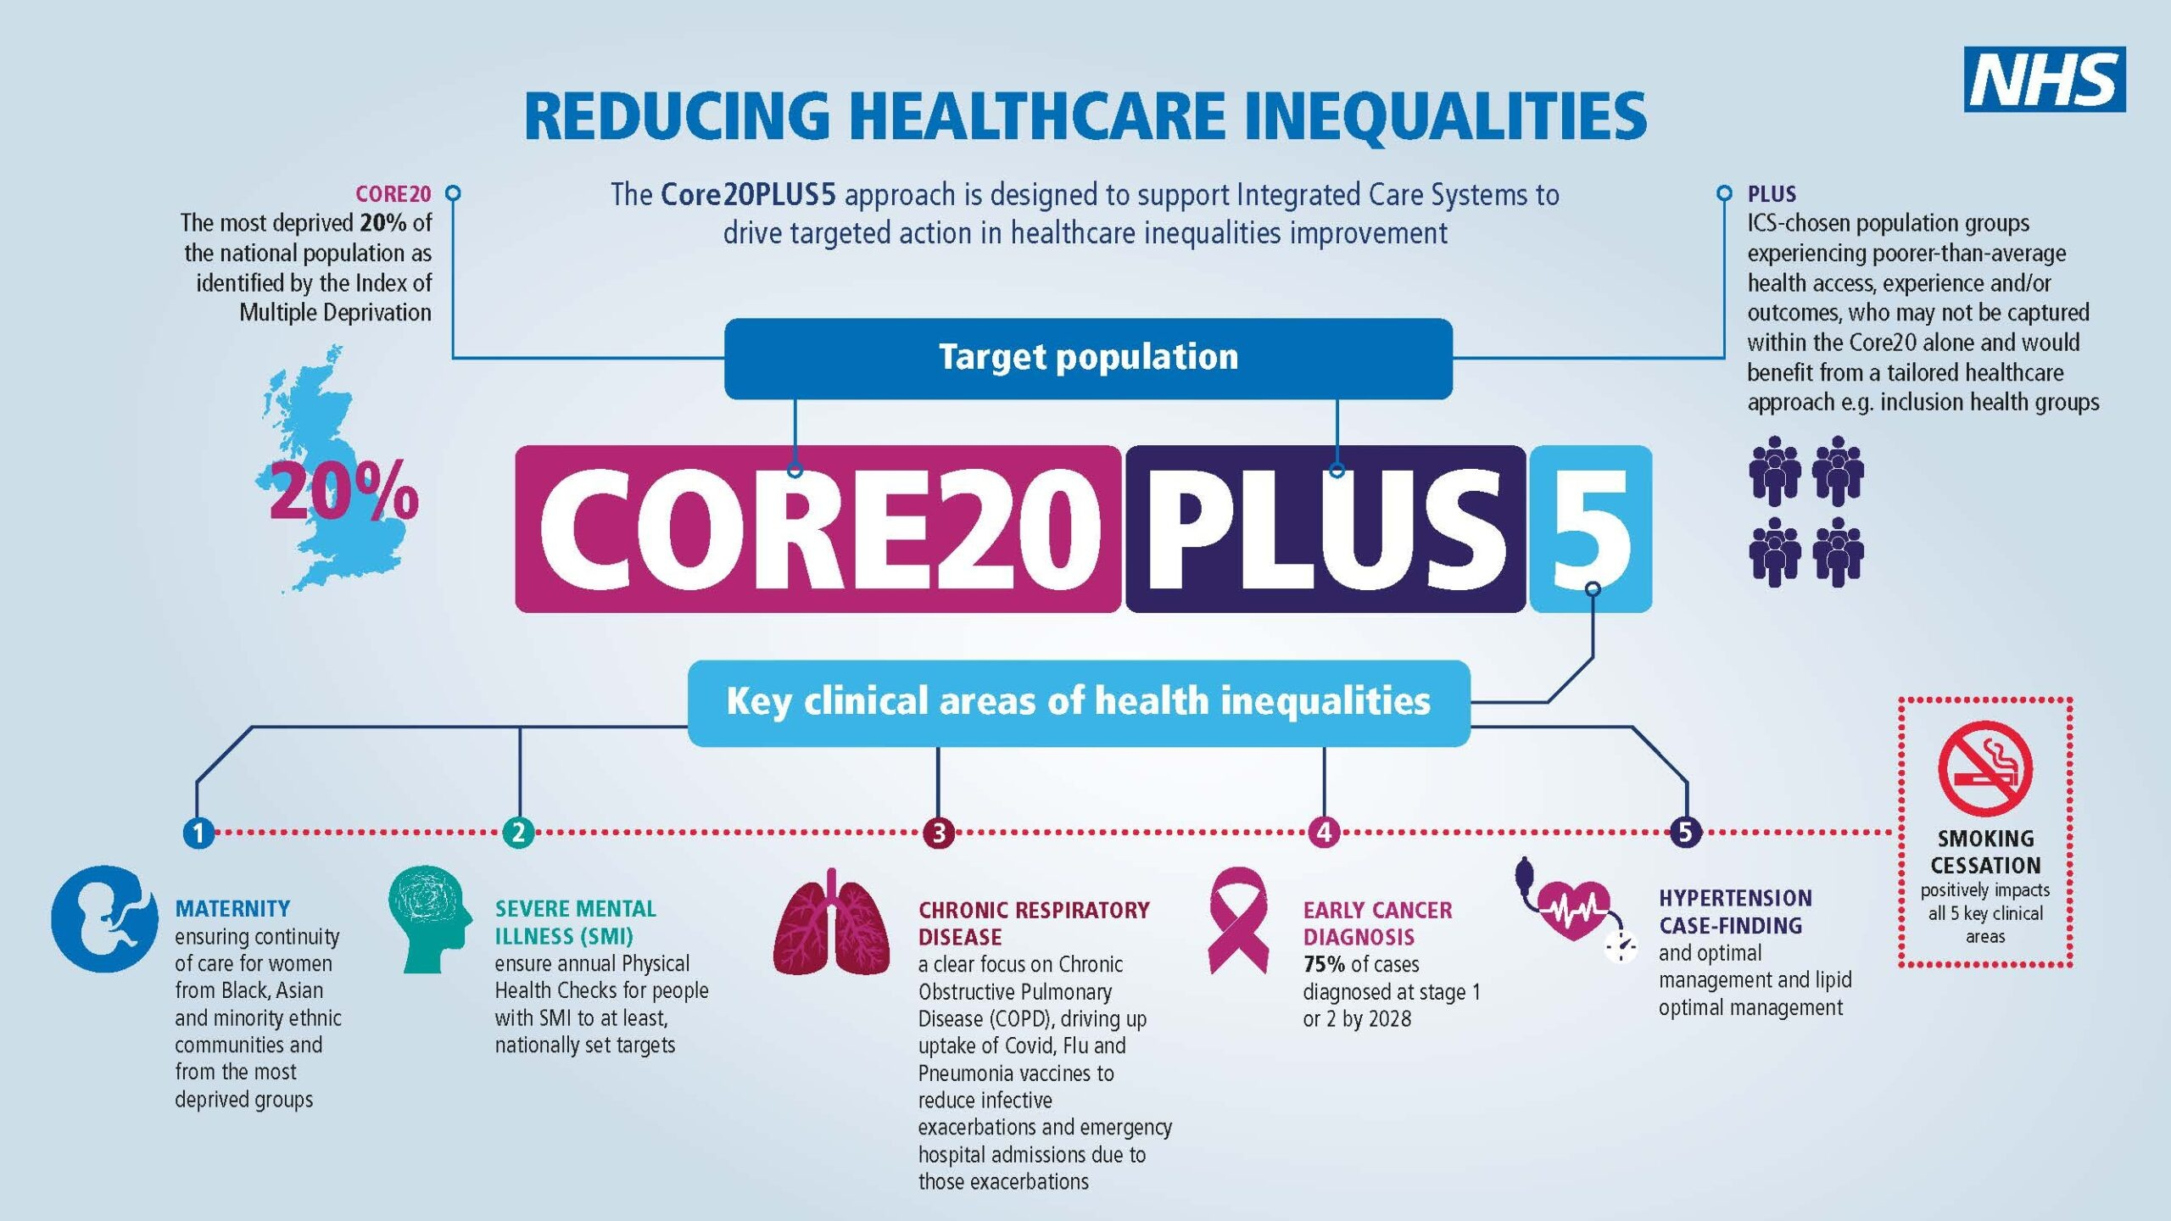

- Identify patients with poorly controlled hypertension - stratified them based on risk factors. Telephone patients also inviting them via text and letter
- Up-skill nurse associate in hypertension management.
- NICE guidance https://www.nice.org.uk/guidance/ng136Health Activation tool
- Dietician
- Exercise groups
- Mental Health support /social prescribing.

Resulted in improved achievement of in target blood pressure (surrogate endpoint). Outcomes of improvement in CVA, MI occurrence and death awaited

However, I could not help getting my energy and enthusiasm from working at strengthening "the seams"!
- Higher incidence of CVD in lower socioeconomic groups
- Lower incidence of bystander CPR in lower SE groups and some ethnic groups
- WHO "Kids save lives"
- Work between GP and local schools forges community links
- Pester power of mobilised children

Aim - pull together
- Prevention and lifestyle messaging,
- Training children in BLS
- Aspiration raising

Working through Coventry Council Head teachers communications I recruited several schools and have delivered the training package in collaboration with the school either to whole classes or after school and with community groups. I have also delivered the training to PCN staff.

3 schools, 96 children, 10 parents and 5 teachers

2 youth groups, 16 children

3 Peer group Primary care sessions, 38 staff

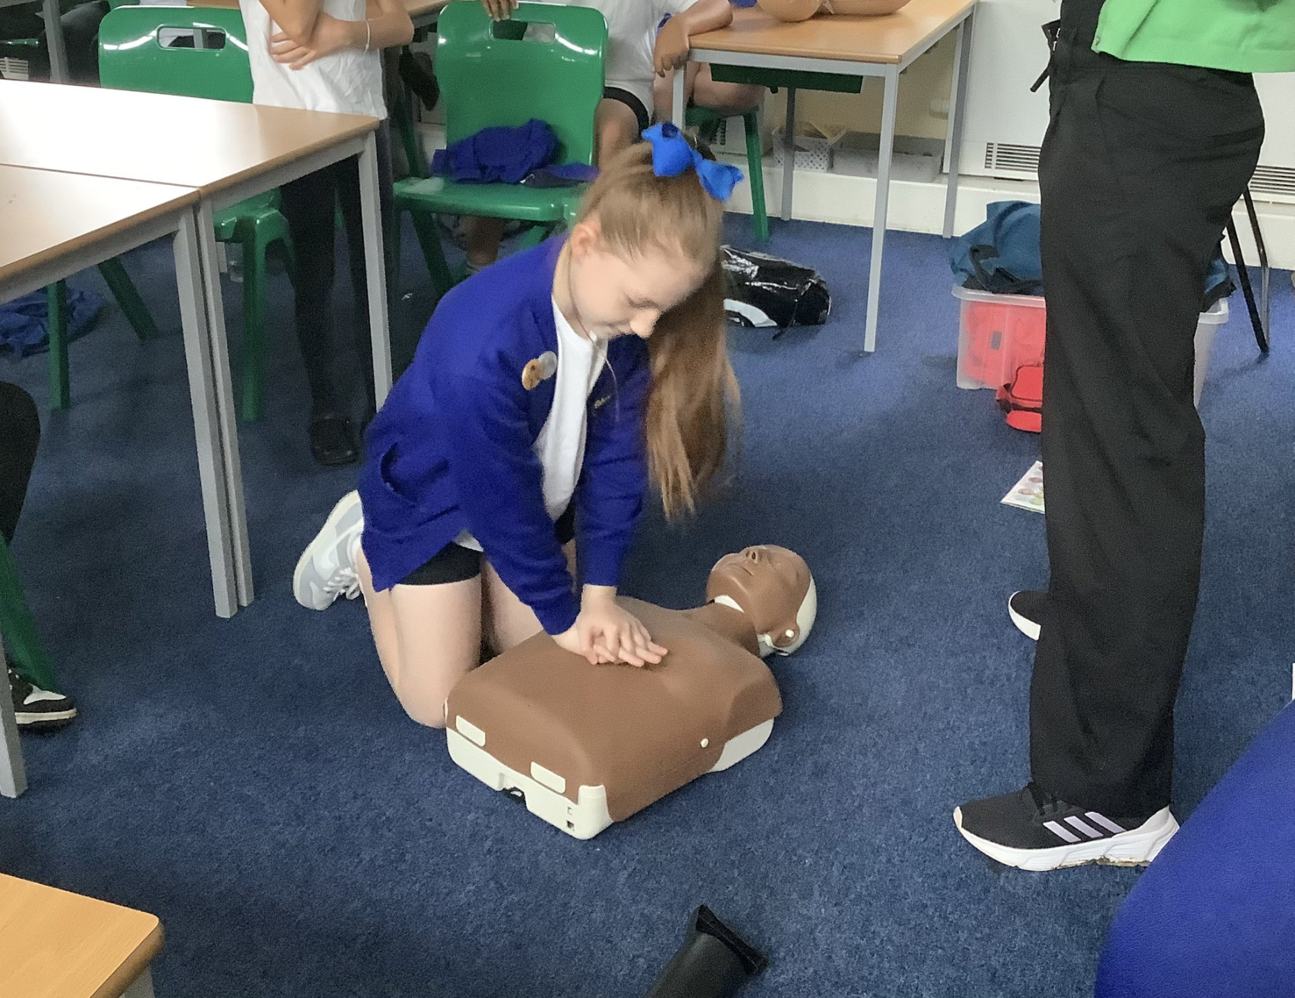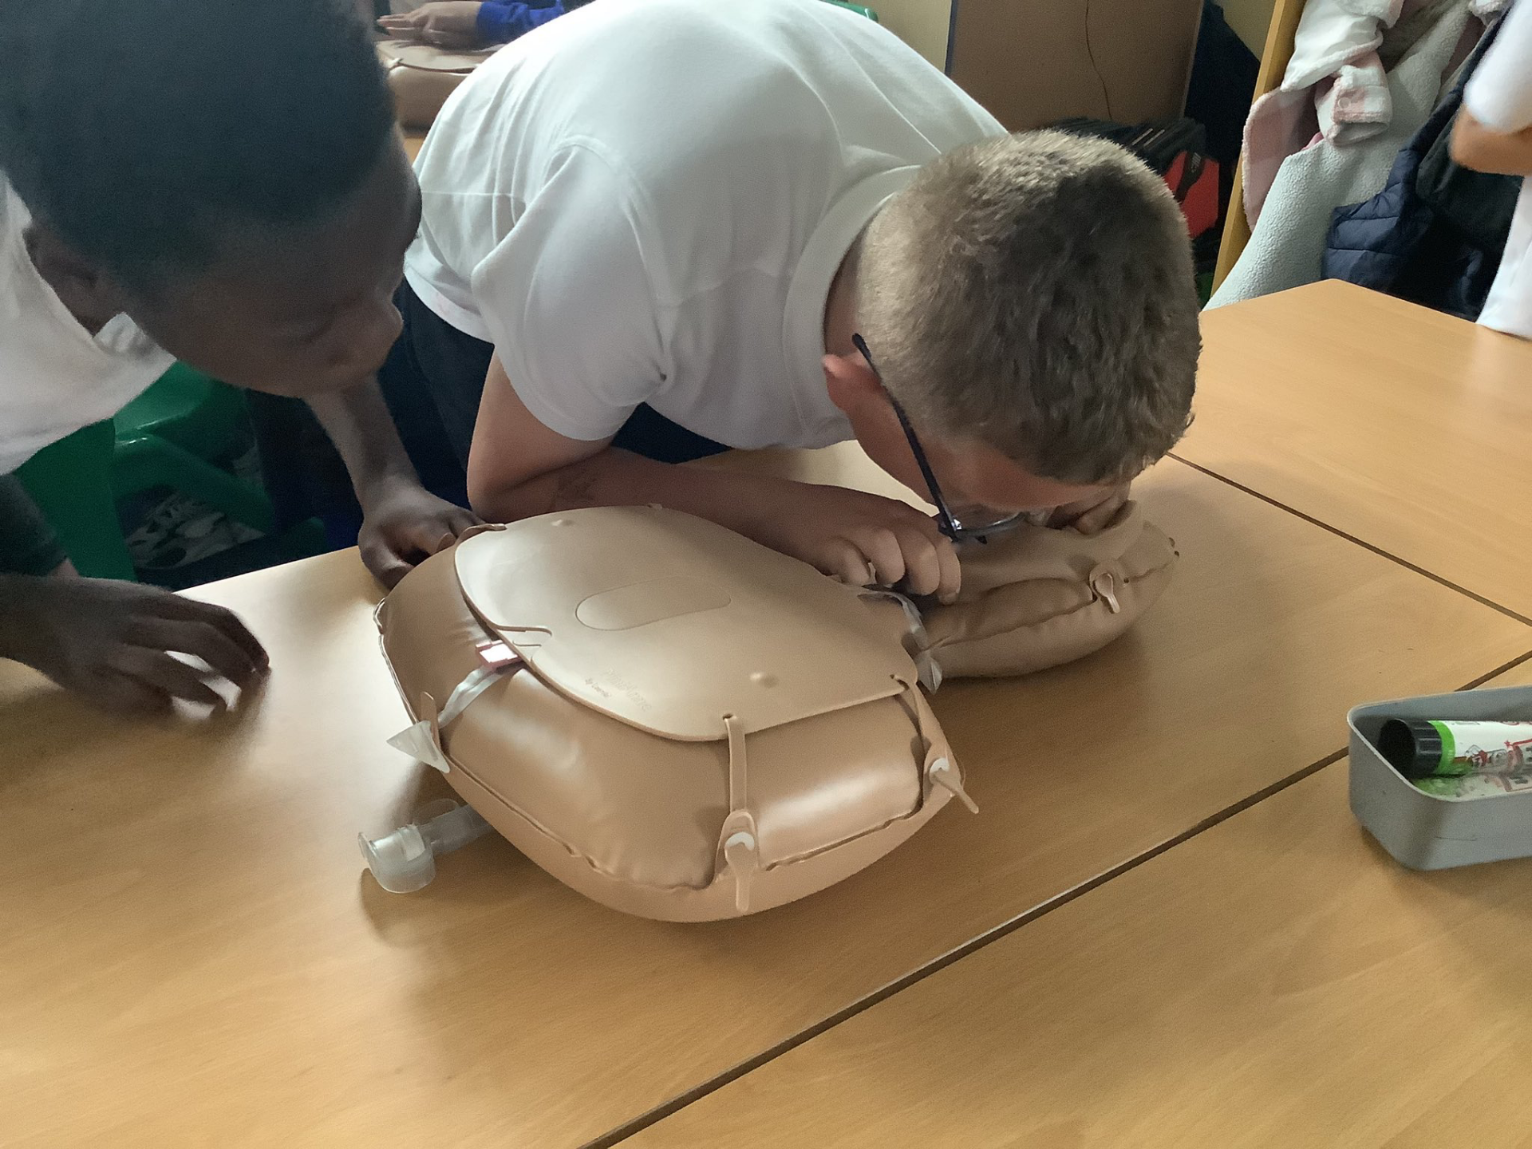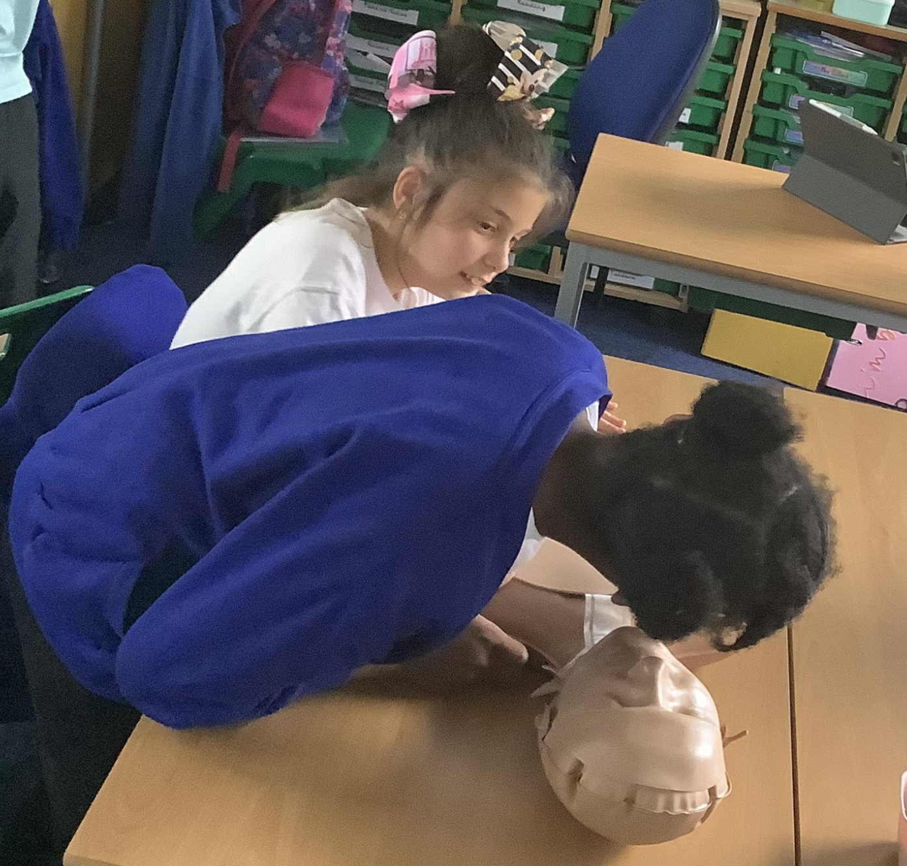
Future plans:

- Revisit schools above on an annual basis
- Willenhall Community training sessions
- Early discussions with local secondary school to train students to co-deliver training to primary schools in their Academy Trust.
- Database of local Primary Care staff willing to train in schools - hope to be able to offer a Coventry wide primary school free, Prevention, BLS, aspiration raising over a 1 month period each year.

Reflections

The fellowship has been really central in helping me shape my practice into something that fits well with my philosophy around HI, wider system and community involvement and keep me passionate about my core values in an increasingly "market society".

I have enjoyed the teaching and training sessions both at face value for the contents learnt and ability to reflect with others as well as for the insights into teaching styles I might employ. Interestingly, it has helped me think about my learning style and revisit study strategies.

If I am disappointed with anything I would point to lack of cohesion/feeling of team with my other fellows and am happy to take ownership of this.

As well as the roll out of BLS training we will continue our PHM approach, while continuing to value one to one interactions and the real impact that a GP can have in the health issues that exist within people's messy lives.

