PRACTICE ASSESSOR TRAINING

.

Practice Education Team: Updated Aug 2023
Practice Assessor Training: SSSA

Introduction
In May 2018 the Nursing and Midwifery Council (NMC) launched ambitious new standards that set out the skills and knowledge the next generation of nurses will learn to enable them to deliver world class care. The NMC also introduced a more modern and innovative approach to the way universities and their practice partners train nurses and midwives.
The new standards represent two years’ work and have been developed alongside nurses as well as, patient groups, students, educators, healthcare professionals and charities from across the UK.
Jackie Smith, NMC Chief Executive and Registrar, said:

“Our new standards represent a huge leap forward. They raise the bar for the next generation of nurses and not only match the demands of the role but the ambition of the profession.
“We’ve also overhauled the way universities train nurses and midwives. They’ll be given more flexibility to harness new ways of working and embrace technology so they can equip the nurses and midwives of tomorrow with the skills they need to deliver world class care for years to come.”
The new standards will give nurses a greater understanding across all four fields of nursing practice, in particular mental health - while also increasing the emphasis on teamwork and leadership. Nurses will also have greater responsibilities in public health and will be given the skills to train as prescribers immediately after qualifying, rather than wait 3 years.
The NMC has also outlined brand new standards for education institutions and practice placement partners - who provide the practical training experience for nurses and midwives. There will be changes to the way students are supervised and assessed with other registered health and care professionals as well as nurses and midwives carrying out the role. This will increase the pool of professionals available to support and improve the quality of student learning. The first nurses can begin training against the new standards as early as January 2019; however, in this region it will be September 2019.
This on-line learning is focused on the points highlighted in bold, in the previous paragraph. These new standards in practice learning are abbreviated as SSSA – this stands for the Standards for Student Supervision and Assessment.

NMC Heading 1

Section 1

Effective Practice Learning

At the end of this section and after completing the one-day classroom session you will be able to:
- Explore what is meant by a culture of learning and identify key strategies to facilitate this.
- Investigate some of the qualities, skills and behaviours to be an effective Practice Supervisor and Assessor.
- Identify opportunities for the integration of interprofessional colleagues to support student learning in practice.
- Demonstrate an understanding of how to develop professional, supportive and productive working relationships with students.
- Reflect on the main reasons healthcare students leave their course and consider what supportive or advisory strategies Practice Supervisors and Practice Assessors can make to reduce under- graduate attrition.

Learning Environment and Learning Culture:
Within the new NMC’s SSSA, a lot of emphasis is placed on the importance of creating the right sort of learning culture and learning environment, as there is a strong commitment that if we get this right, students can maximise their learning.

Activity 1:
The NMC uses several words to describe its vision of an environment conducive to learning. Review these and beside each, give a different example of what you would do as a Practice Supervisor to address this. Each word should be related specifically to student learning e.g. the word ‘safe’ requires you to state how you would make a student feel safe in the clinical learning environment, rather than giving examples that are associated with patient safety.

NMC Descriptors | Your Examples
Safe
Inclusive
Ethical
Open
Honest

Changing a learning culture is not something you can do single-handedly because if we want change to be embedded and sustainable, most of the other people in the clinical environment need to embrace the changes too. Consider how you can influence others: including colleagues and students.

Activity 2:

A project by the Kings Fund suggested there were six components to a ‘healthy culture’ in the workplace. Look at the list below. When working in your capacity as a Practice Supervisor or Practice Assessor, tick which of these factors you think you could influence:

Goal  https://www.kingsfund.org.uk/projects/culture | Yes | No | Maybe
1. Inspiring vision and values
2. Support and compassion
3. Goals and performance
4. Learning and innovation
5. Effective teamwork
6. Collective leadership

Reflecting on your responses, consider which you feel are out of your reach, and why? Similarly, which do you think you will have the most success achieving, and why?

As a Practice Supervisor moving towards becoming a Practice Assessor you are a key member of the educational team helping students to apply their university learning in a practice-based situation. As well helping with this transfer of knowledge between the different learning settings, you are also facilitating students to develop insight that whilst student satisfaction is a central theme at the university, in a clinical setting, it is patient safety and well-being that must take priority.

Activity 3:
Reflect on the diagram below. Think about some of the skills and qualities you will need to support students, especially with the junior ones who need to make the transition of understanding why the patient must sit at the heart of everything we do in clinical practice:

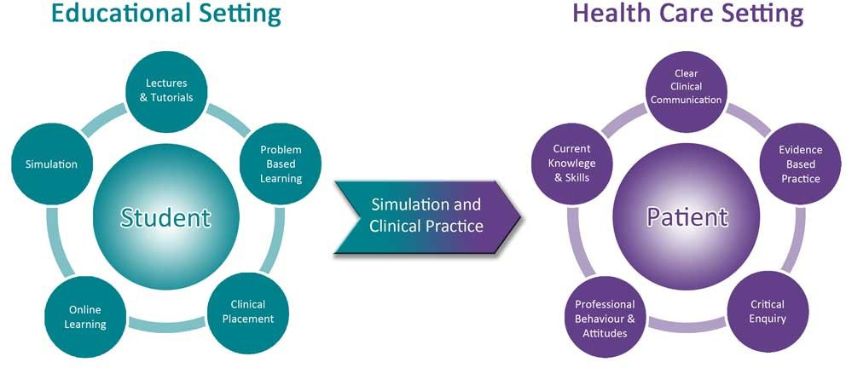

List any further thoughts or ideas below:

Supporting Students and Effective Working Relationships:
There are a range of things we can do to support students when they first arrive in the clinical area. You are already probably doing all of these as part of your role as a Practice Supervisor. What sorts of things do we do to make students feel welcome? Think about the activities you are required to do in the MYEPAD at different points in the placement. A few examples are listed to get you started:

Activity 4:

 | Activity
Start of Placement | - Informal visit  - Greet the student by their name on the 1st day  - Welcome pack
Middle of Placement
End of Placement

Maslow’s Hierarchy of Need is a concept that can be adapted to illustrate how students may feel on placement. Unless certain needs e.g. support and effective relationships are in place, it is difficult for students to feel secure during the experience, affecting their capacity to ask questions and learn.

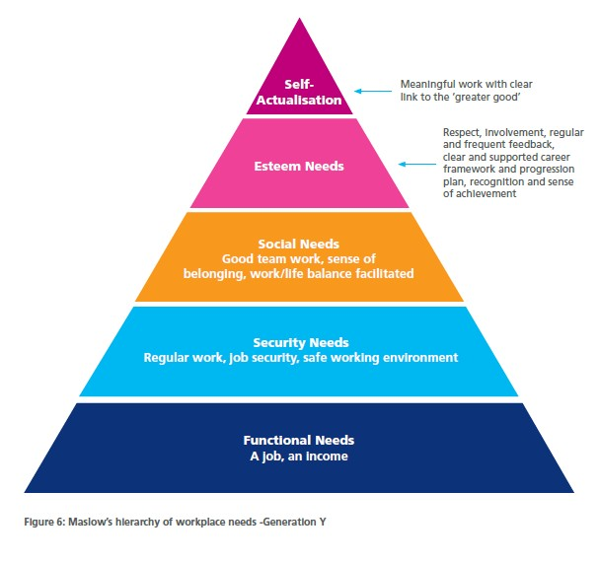
Top three reasons why students have considered leaving the course

1. Personal Finances – little or no opportunity to earn money. 2. Academic concerns – academically challenging, not knowing well in advance about practice placements and poor standard of lecturing.
3. Placement – not personally prepared for the clinical experience in year one. Top three reasons why students have never considered leaving the course 1. The end goal. 2. The personal ambition to be the
chosen professional 3. Support from family and friends.
RePAIR Insight into the stakeholders’ experience Background and Context Introduction Approach to
3. Support from family and friends.

Activity 5:
Reflect on your clinical area - are these student ‘protective factors’ in place?

Levett-Jones and Lathlean (2009) introduce the concept of ‘belonginess’ within any group. They emphasise that it is very important for a person to feel secure, accepted, included, valued and respected. In addition, they must feel connected to the group, and that their professional and personal values are in harmony with the team they have joined. If a student feels these things are in place, it has a positive effect on their learning, it facilitates their socialisation and it increases their motivation at work.
How do we build an open, honest and ethical culture? Walsh (2014) suggests the following qualities and behaviours are particularly important. By qualities we mean how all Practice Supervisors and Practice Assessors perceive students and how this makes the student feel.













Genuine
Respectful
Practice Supervisors and Practice Assessors Need To Be:
Empathetic Non-judgemental

Activity 6:
Are there any additional qualities you would add because you think they are important for Practice Supervisors and Practice Assessors to have as a foundation to effective practice learning.

Practice Supervisors and Practice Assessors also need to have a range of behaviours that will help them in their role, as how they interact with students to facilitate learning and assessment is very important. The image below summarises some of the key behaviours they need to demonstrate. By behaviours we mean the advanced communication and interpersonal skills that practice educators need to use, as these also have a huge influence in how the student is made to feel and whether the student believes this professional is engaged and invested in their learning.



























Active Listening
Paraphrasing
Effective Body Language
Reflection
Practice Supervisors and Practice Assessors Need to Use
Emotional Intelligence
Open Questions
Activity 7:
Are there any additional behaviours you would add because you think they are important for Practice Supervisors and Practice Assessors to have as a foundation to effective practice learning.

With the new NMC Standards there is a clear recognition that some of the teaching and supervision of student nurses can be provided by the wider interprofessional team. In Part 1 of the Standards Framework for Nursing and Midwifery (NMC, 2018, pp.5) it is specifically stated that:
“We will only approve programmes where the learning culture is ethical, open and honest, is conducive to safe and effective learning that respects the principles of equality and diversity, and where innovation, interprofessional learning and team working are embedded.”
The wider teams we work with can be a big support to our students, so all Practice Supervisors and Practice Assessors should be networking and utilising them as invaluable resources. With assessment in mind, they can also contribute, by providing feedback about our students which helps to generate objective evidence, to inform your assessment decisions, and to increase the reliability of the assessment process.

Activity 8:
List the specialist staff and broader interprofessional team who could help you to support student learning in your clinical area:

All Professionals Working in my Clinical Area
1. Doctor | 8.
2. | 9.
3. | 10.
4. | 11.
5. | 12.
6. | 13.
7. | 14.

Another way we can support students is to be mindful of the reasons why they may leave the course. Health Education, England published a report called RePAIR (2017) which examines the attrition of health care professionals, including student nurses and midwives.

Activity 9:
Please see the graphs below. It is worth focusing on the ‘avoidable reasons’ for leaving, especially if some intervention(s) may have helped prevent it.
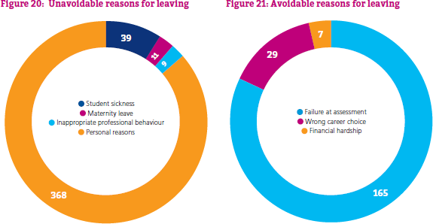

Review Figure 21: assessment is the main reason for leaving by a large margin; some of this data will clearly be related to failing academic assignments, however, an unspecified proportion are practice assessments. Are there any actions you could take, as practice educators, to alleviate student pressures related to assessment, wrong career choice, or finance?

Problem | Possible Actions
Assessment
Wrong career
Finances

The graph below is based on an attitudinal survey of the reasons why student nurses and midwives were thinking about leaving. The multitude of pressures and stresses listed below give all Practice Supervisors and Practice Assessors ‘food for thought’. These findings suggest there is still more work to be done to create effective learning environments, where all students feel part of a positive learning culture, in which they are included, valued, supported, and respected. As a clinical educator it is important you are aware of the university’s new policy/guidance on Escalating Concerns (see Appendix 1) in case a student ever discloses a relevant issue that needs to be referred for further investigation.

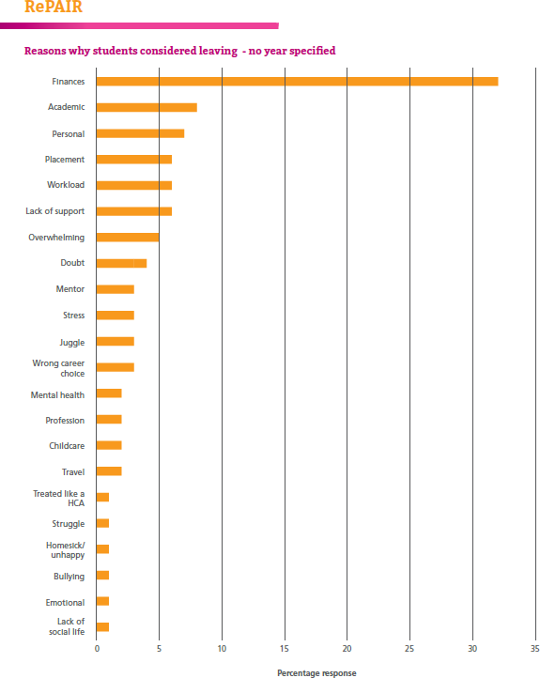

The RePAIR group did a follow up study in 2020 to assess the impact of covid on student attitudes and feelings; if you want to look up the finding the link is in the reference list at the end of this workbook under ‘Health Education, England’.
In summary, effective practice learning is something we must all be working together to achieve. It is vital there is culture of collaboration between colleagues within and across clinical areas, the university, the students and the patients being cared for.

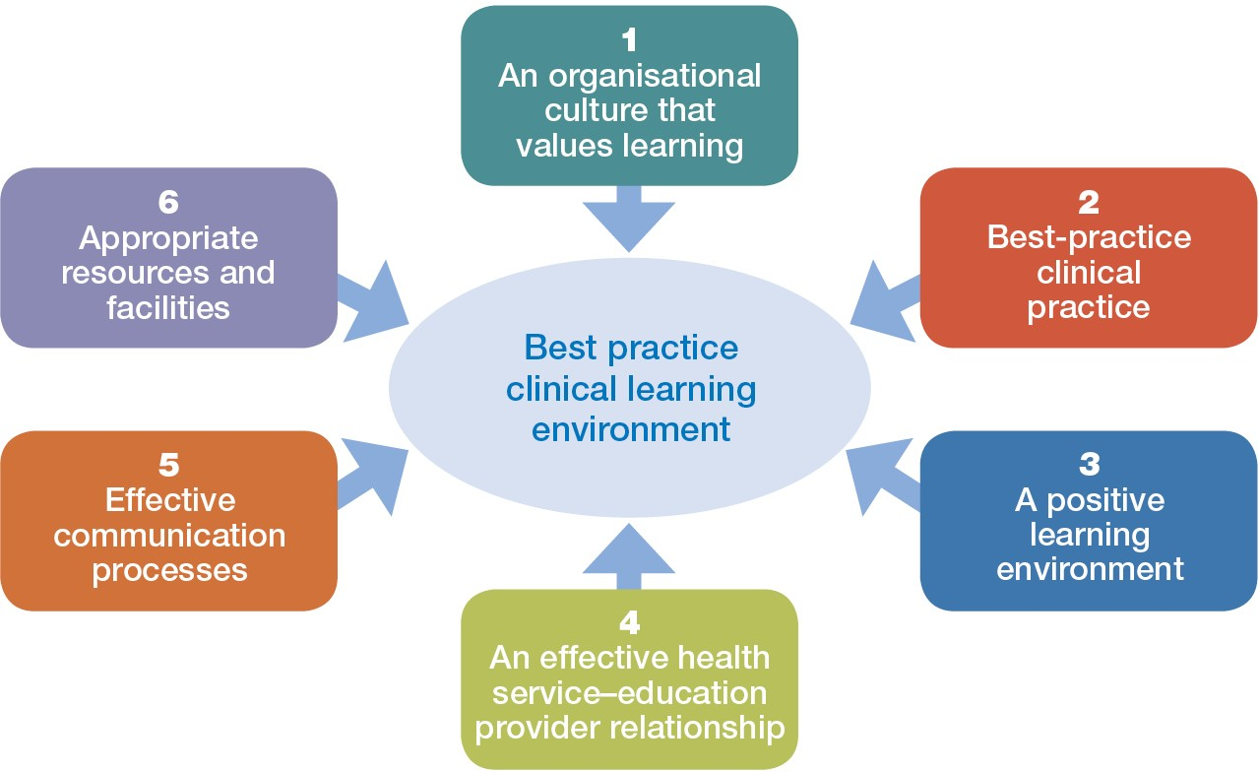

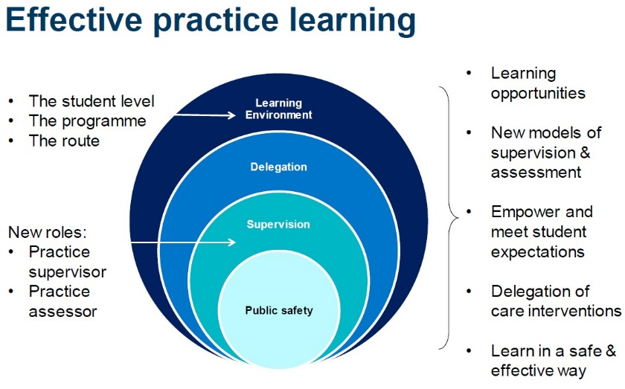
Whilst the diagram above contains many of the general factors to consider when supporting students in practice, there is one crucial factor we must not forget to highlight: public safety remains at the core of what we do, and we must be firm about failing students who are not meeting the key learning standards set by the NMC.
NMC Heading 2

NMC Heading 2:

Section 2

Effective Supervision of Students

At the end of this section and after completing the one-day classroom session you will be able to:
- Review and discuss the role of Practice Supervisor.
- Explore the coaching approach to practice learning and tease out how it differs from the previous mentor role.
- Examine how to promote student empowerment through using coaching style questions and peer learning.
- Engage with basic learning theory and consider how to apply this to practice learning.
- Identify models of student supervision that place emphasis on a whole ‘team approach’ to how students learn in practice and which help practice educators develop a more consistent and structured approach to clinical learning.

This training is focused on up-skilling you to become a Practice Assessor, however, it is important to remember you will still have an on-going responsibility to also be an effective Practice Supervisor. The key point to remember is that you are not permitted to act as a Practice Supervisor and Practice Assessor to the same student.
Therefore, before looking specifically at the Practice Assessor’s role, it is important to revise and review the Practice Supervisor’s role. The Practice Supervisor role has many similarities to a mentor, hence most of the NMC’s broad requirements for Practice Supervisors should be reassuringly familiar to you. The NMC say Practice Supervisors must:
- Act as a role model of effective practice in line with The Code (2018).
- Support learning in line with their scope of practice, enabling students to meet their proficiencies and programme learning outcomes
- Support and supervise students, ensuring feedback is provided on progress to help them achieve the required proficiencies and skills.
- Have current knowledge and experience of the area in which they are supporting, supervising and providing feedback to students.
- Receive on-going support to participate in the practice learning of students.
The contrast between a Mentor and a Practice Supervisor contains several key differences which are summarised in more detail later. At this point we are going to focus on two of them:

- The mentor role included both the supervision and assessment of a student; each role is now divided between two different people.
- The way you facilitate learning is moving towards a ‘coaching-style’.

Activity 10:
Regarding the first point, why do you think the NMC decided it was a good idea to separate the supervision and assessment roles? Remember, this change came out of a long consultation about how to improve nurse/midwifery training. Write your ideas below:

The second of the differences, gives us a chance to explore what is meant by a coaching approach to support student learning.
John Whitmore (2017, pp.12-13) is considered a contemporary expert in coaching and he defines it as:
“…unlocking people’s potential to maximise their own performance.”

Activity 11:
The concept of ‘unlocking’ a student’s potential is the key point to think about. Did we always do that as a mentor? Look at the diagram below and reflect on what it is trying to draw attention to by suggesting mentors are focused on ‘advising’ and coaches on ‘asking’. Consider the impact these different approaches may have on the students:

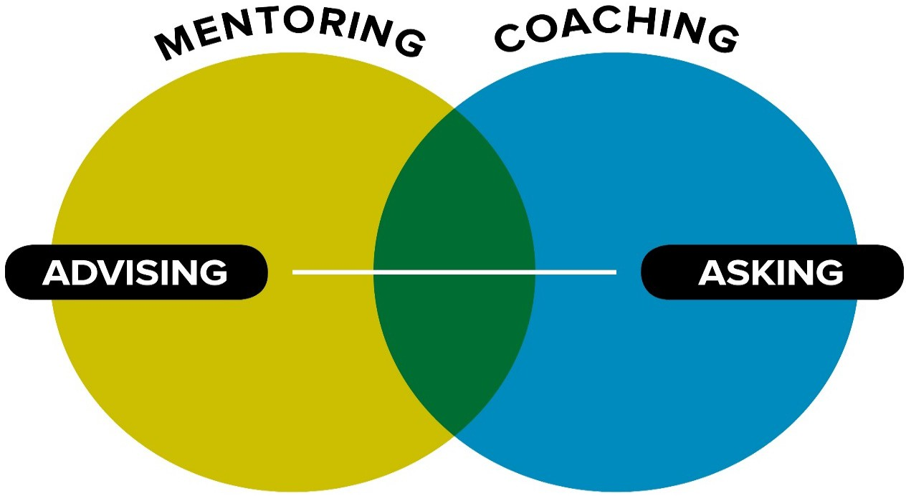

Reflections on the Student Impact
Mentors Advise
Coaches Ask

Activity 12:
Look at the diagram below. What does it tell you about the differences between being a mentor and a coach? A mentor would typically ‘push’ their students and the behaviour of a coach’s firmly sit with ‘pull’. What do you think are the differences between pushing or pulling students ? Based on the diagram, what do the words ‘pull’ and ‘push’ mean in the context of how we should be supporting our students to learn ? You may wish to re-visit these questions after you have learnt about surface and deep learning on pages 18- 20.

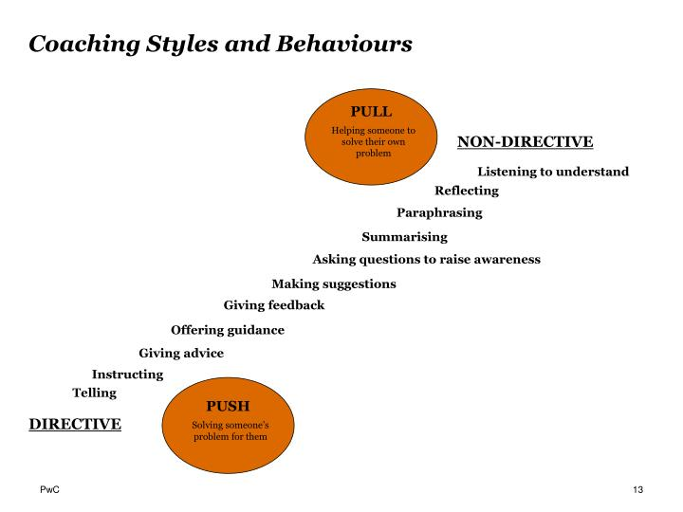

Coach

Mentor

Write down a few of your main thoughts to the questions above:

In a coaching approach to learning, one of the main skills you need is to develop is a technique of how you ask students searching questions. In other words, there is an art to asking coaching questions. This focuses on the Practice Supervisor (the ‘coach’) encouraging students to explore and utilise their own knowledge, so they are more involved in working things out for themselves. The diagram below indicates the main responsibilities you will have as a ‘coach’ and the student as the coachee.

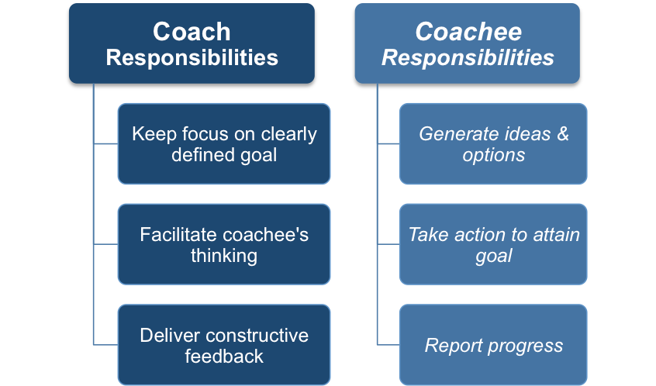

As mentors staff were encouraged to share our expertise with students. Students generally like this form of learning because they get immediate answers to their questions. However, the mentorship model promotes a relatively passive role for the student, often only producing surface learning - this meaning a lot of what was taught was forgotten in a few days. The coaching approach recognises this and advocates if we harness the student’s potential to be more active in how they learn, this will help them to expand and strengthen what they already know, enabling them to construct lasting knowledge. A Practice Supervisor who can skilfully deliver coaching style questions can facilitate students to develop deep learning.

Activity 13:
Review your responsibilities. What are your main concerns about this role?

Activity 14:
In a coaching style relationship, it is suggested the balance of talking is 80%:20%. The student should be doing most of the talking.


What are two good reasons to encourage students to talk more about their learning ?

1)
2)

The diagram below illustrates some of the ways coaching questions can be slanted to engage students more actively.




Foster Commitment

Focus Attention
Questioning
Enables a Coach to:
Encourage Exploration
Elicit New Ideas

19

If we go back to our definition of coaching about ‘unlocking potential’ this is what this approach aims to do. It is impossible to prescribe exactly how to do this because each Practice Supervisor must assess a student’s capabilities at the beginning of a placement, providing help and guidance depending on the individual student’s circumstances.
Coaching is not the only model to realise that engaging students develops deep learning. The ‘Cone of Learning’ has been around since 1946 and this has now been adapted into the Learning Pyramid. This suggests which teaching activities help people to retain the most amount of information.
Practice Supervisors are very well-placed to maximise student learning as their routine activities are aligned with all the most influential forms of teaching: demonstration, discussion and practice by doing.
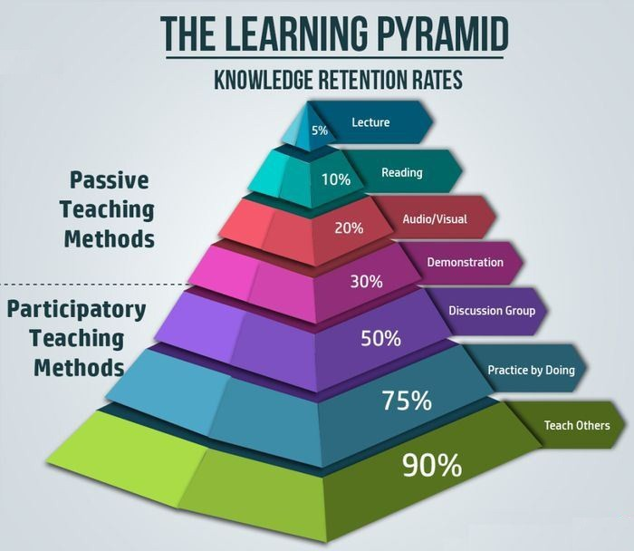
‘Teaching Others’ is the most significant, with a 90% retention rate. Therefore, the NMC suggests practice staff should encourage it, in the form of peer learning. For example, if a 3rd year student is facilitated to teach a less experienced student, it benefits both the person receiving the teaching, as well as the person delivering it. ‘Teaching Others’ is something a Practice Supervisor will be doing regularly, so this model also highlights that a qualified practitioner is helped to hone their own skills and knowledge by teaching it to others, developing enhanced understanding in their own field.
20

Activity 15:
Consider the clinical area where you work. If you were going to promote a programme of peer learning between students, suggest at least two possible topics, students at different stages of their training, might be able to teach another student:

Student Stage | Teaching/Learning Activity
1st Years | 1)  2)
2nd Years | 1)  2)
3rd Years | 1)  2)

It is also useful for a Practice Supervisor to have some knowledge of learning styles. If we understand how a student learns best, we can adapt the approaches we use to maximise their potential. Honey and Mumford (1982) have become well known for their work on learning styles. They developed a questionnaire, that once completed, could indicate a person’s favoured way(s) of learning. They concluded there were four main styles: Activist, Theorist, Pragmatist and Reflector. Most people will display elements of all four styles in the responses they gave, but the most useful outcome is to determine whether an individual can be aligned to having certain distinct preferences towards one or two of these, because if certain dominant traits can be identified, practice learning can be modified to tap into these strengths.

The table below is a useful summary of learning styles which may help you, when working with a student, to tailor your approach and plan future learning activities.
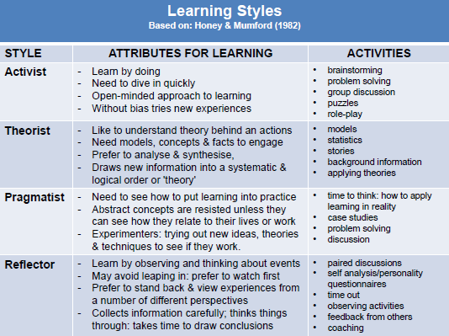

Many students who come to work with you may have already done one of these learning style questionnaires in college or university and know their preferred learning style. Sometimes you can almost work it out for yourself because you have already observed how the student seems to be ‘naturally’ drawn towards exhibiting certain learning behaviours, asking certain types of questions, or thinking through clinical problem in a particular way.
As with any learning model, always discuss your thinking with the student, so they are actively involved in the process. Sometimes, it’s a good idea to ‘stretch’ them; so, if your student seems to be mainly an activist and you have accommodated this to begin with, think about giving them some activities and learning opportunities to develop other styles, such as their ‘hidden’ theorist or reflector.
There are many different learning style questionnaires available on-line. The questionnaires highlight how people learn in varied ways. For example, some individuals are visual learners, liking to process information using flow charts, diagrams, graphs etc; others are auditory learners and like to listen to information; some learn best if they can read or write about a subject; and others prefer to learn through ‘doing’ and having hands-on experience. This learning tool is abbreviated as VARK and the table below summarised the main points:
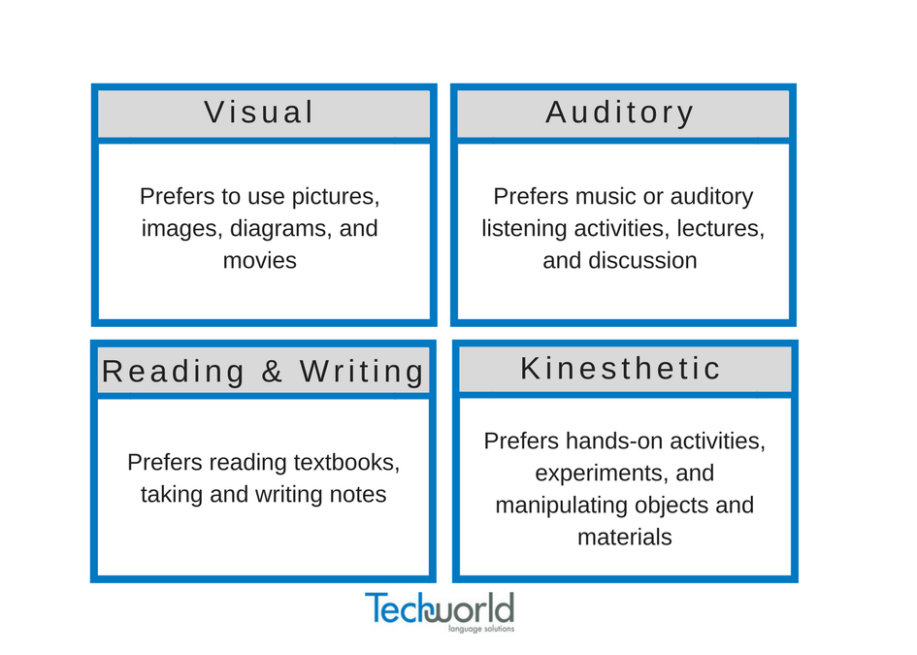
VARK Learning Styles
The general learning theories and models discussed so far, all fit with a coaching approach. A useful strategy to remember the coaching approach is the ‘T-GROW Model’. The diagram below, illustrates what it stands for and some examples of the questions you could ask at each stage. In some resources it is just called the ‘GROW Model’ and the T (for Topic) is left out. In practice learning the Topic is an essential addition, because otherwise you will not have a clear focus to ‘hang’ the GROW on. For example, if you start to identify learning goals with a student, without a focus, the goals will become random and probably cut across many areas of clinical learning. If you identify a Topic, like ‘medicines management’, it then gives all the GROW questions a clear and specific direction and emphasis.
Please see below two diagrams to help you understand how the GROW model can be used in clinical practice, to assist students to use the coaching approach.

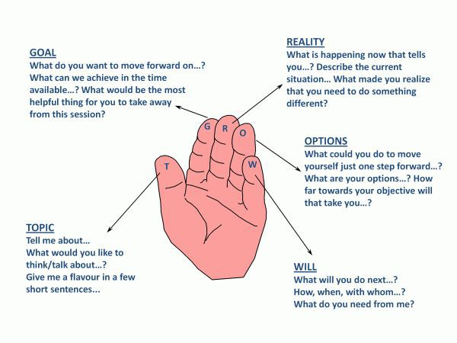
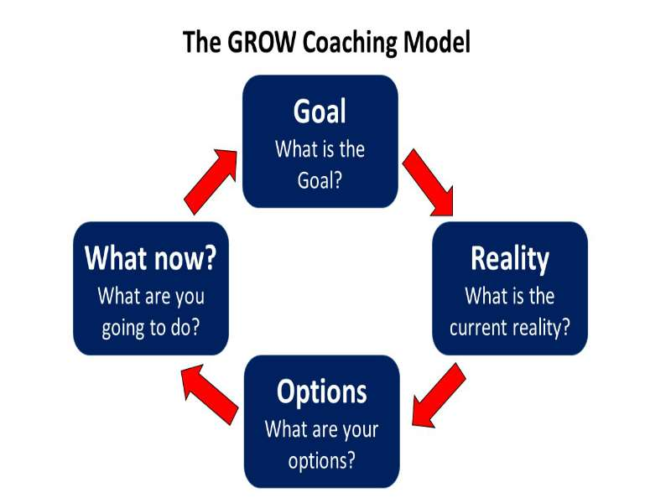

Activity 16:

Please spend a few minutes reading through examples of coaching-style question:

GROW Coaching-Style Questions

Goal:  - What do you want to achieve?  - What do you want to do?  - What level do you want to reach?  - What is the time-frame to get there?  - Where do you want this to lead?  - What’s the key area to focus on?  - What is the goal for this session?  - How far will you get today?  - What are your end outcomes?  - What intermediate steps will help?  - Which learning outcome is it relevant to? | Reality:  - Where are you now?  - What have you already done?  - How can it be improved?  - What would you do if XX happened?  - What level are you currently at?  - Who/what else might influence your progress?  - What action have you taken so far?  - What stopped you from doing more?  - What obstacles do you see?  - What resources will help?
Options:  - How can you achieve this?  - Does your goals align with Trust Policy?  - Ideally what would you do?  - What problems have you had ?  - How will you address these ?  - What else could you do?  - Would you do anything differently if you could start again ?  - What are the disadvantages or advantages of XXXXX?  - What would give you the best result?  - Which solutions seems best ? | Will/What Forward/What Now:  - What’s the 1st thing you will do?  - How will you overcome obstacles?  - Are you sure you can achieve this?  - What steps will you take?  - What will you do to eliminate external or internal factors?  - What can I do to support you?  - What commitment do you have, on a scale of 1-10 to complete this?  - What prevents it from being a 10?  - What skill can be signed off?

Whereas the first model to guide your supervision used ‘GROW’ as a prompt to help structure your coaching conversations, an alternative way of looking at student supervision is to use the ‘CLEAR’ Model. This shares some similarities with the GROW model, as again it focuses on acting on key words. The term ‘contract’ or ‘contracting’ is used widely in coaching to simply mean the coach (Practice Supervisor/Assessor) sits down with the coachee (student) to agree how the two of them are going to work together; a good example of contracting is the initial interview when aspirations, learning needs, boundaries etc are agreed.

CLEAR | What Is The Practice Supervisor Doing ?
Contract | - Acquiring clarity around current learning needs  - Discussing student goal(s)  - Agreeing what the student is doing
Listen | - Developing a shared agreement over activities for that day (week, month etc)  - Considering the student’s perception of the goal  - Understanding the student’s situation, especially if barriers are anticipated
Explore | - Identifying the facts  - Confirming what’s already been attained; can any past learning support current goals  - Examining the student’s feelings, providing support, building confidence, identifying motivational factors etc
Action | - Discussing the best way forward  - Rehearsing the first steps with the student  - Facilitating a realistic plan to promote the student to succeed
Review | - Reviewing student actions  - Providing constructive verbal & written feedback  - Outlining future options for student development

In summary, this section highlights how the NMC has preserved many of the key principles of being a successful mentor and still expects Practice Supervisors to act as role models, provide regular feedback to students and colleagues, update their professional/clinical knowledge and participate in any training to develop and improve their skills as a facilitator of learning.
The new standards also promote some new initiatives, such as, adapting a coaching approach and encouraging peer learning as pivotal elements of practice learning. The table below is a summary emphasising some of the main differences between being a mentor and a Practice Supervisor. This provides a clear direction of how you must change both your mindset and behaviour to be a clinical educator in the future.

Comparison of Old and New Roles
Mentor | Practice Supervisor (‘Coach’)
Identifies individual learning activities in the clinical environment | Uses the whole ward as a learning environment
Allocates work to the student | Is allocated work by the student
Answers questions | Asks questions
Is observed by student | Observes the student
Shows the student how | Is shown how by the student
Steps in to provide care | Steps out allowing the student to learn through ‘doing’ (the care)
Focused on teaching students | Focused on students learning
Instructs student learning | Student shows the coach what they have learned
Does the same work as before, but with a student | Works differently while coaching to facilitate student empowerment & independence
Adapted from work by Karen Thom, clinical educator at James Paget Hospital, Norfolk.

NMC Heading 3:

Section 3

Effective Assessment of Students and Confirmation of Proficiency

At the end of this section and after completing the one-day classroom session you will be able to:
- Review and discuss the role of Practice Assessor.
- Identify the main sources of documentation that would contribute to an ‘object evidence-based assessment’.
- Explore and discuss the key principles of robust assessment.
- Revise understanding of accountability and specifically relate it to the educational role of the Practise Supervisor and Practice Assessor.
- Observe an NMC Webinar entitled The Role of the Practice and Academic Assessor’, making detailed notes on the role of Academic Assessor.

The NMC (2018) states that:
“Student assessments are evidence based, robust and objective. Assessments and confirmation of proficiency are based on an understanding of student achievement across theory and practice. Assessments and confirmation proficiency are timely, providing assurance of student achievement and competence.” (pp. 8)

The NMC stipulate that the Practice Assessor’s responsibilities are to:
- Conduct assessments to confirm student achievement
- Formulate assessment decisions, informed by feedback sought from the Practice Supervisor
- Make and recording objective, evidence-based assessments on conduct, proficiency and achievement, drawing on student records, direct observations, student self-reflections and other resources
- Maintain current knowledge and expertise relevant to the courses they are assessing on
- Work in partnership with the nominated Academic Assessor to evaluate and recommend the student for progression for each part of the programme
- Ensure they have made sufficient periodic observations of the student to inform decisions about assessment and progression
- Facilitate sufficient opportunities to gather and coordinate feedback from Practice Supervisors and other relevant people, to be assured about their assessment decision
- Have an understanding of the student’s learning and achievement in theory
- Ensure communication and collaboration is scheduled between practice and Academic Assessor, at relevant points in the student’s programme and progression
- Ensure they are not simultaneously the Practice Supervisor and Practice Assessor for the same student
- Be familiar with the NMC Standards for Prescribing Programmes if assessing students on an approved NMC approved prescribing course

One of the biggest distinctions the NMC require of Practice Assessors is that all assessment decisions are evidence-based. What this means, is that assessments must be based on documented, objective evidence, rather than any subjective, personal impressions or feelings a practitioner may have about a student. In theory a Practice Assessor need not even work in the same clinical area as the student; however, most Practice Assessors choose to undertake some direct observation of the student working in
the practice setting to help them to make an informed, accurate decision based on the evidence in the MYEPAD.

Activity 17:
Think about all situations in which something may be documented about a student on placement. Based on the specific NMC responsibilities listed on the previous page, we already know about some of these, as indicated on the table below. Make a list of where else a Practice Assessor could look for feedback about a student’s progress, competence, or professionalism.

 | Source of Evidence a Practice Assessor Could Use
1 | Practice Supervisor’s notes (at least weekly progress report)
2 | Student self-reflections
3 | Own notes on direct observation of student working in clinical area
4
5
6
7
8
9
10
11
12

Recap on the Purpose of Assessment:
Often, as practice educators, we tend to focus on assessment as only being about how we measure a student’s clinical competence. Understandably, our Regulators, whether the NMC or HCPC, tend to focus on this too as an important part of their remit is to ensure the suitability of people who are entered onto their professional registers. However, it is worthwhile revising the purpose of assessment, to ensure we use it as effectively as possible. The main key functions are listed in the table below.

Activity 18:
Reflect on the list which is presented in a random order. If you had to rank each ‘Assessment Purpose’, in order of importance to you as a Practice Assessor, how would you order it?

Importance | Purpose of Assessment
Most Important = 1 Least Important = 8
 | Monitor progress
 | Provide formative feedback
 | Uncover learning needs
 | Motivate the student
 | Assess level of competence
 | Assess knowledge, skills and values
 | Measure the effectiveness of teaching
 | Safeguard the public

Types of Assessment:
As a Practice Assessor you would hope to see evidence that the student has been exposed to a breadth of assessment types. This would include:

- Continuous assessment
- Formative assessment
- Summative assessment
- Self-assessment (e.g. specific tools, SWOT analysis, action plan)
- Criterion-referenced assessment
- Peer assessment (documented in MYEPAD for 2nd or 3rd Year students)

If this variety of assessment is not apparent by the mid-point of the placement, it would certainly be something you would want to discuss with the Practice Supervisors, suggesting more variety needs to be introduced.
The mid-point interview is crucial in the student’s learning journey, as it is often one of the key moments when the student’s progress is formally evaluated. It is the most common time in a placement when an action plan is written for a student who is under-performing.
Practice Assessors must also be adopting a coaching approach in how they facilitate the assessment, so should be using this meeting to focus on maximising the student’s future potential to develop. This would include coaching conversations about such things as:

- Gaps in knowledge or skills
- Areas of professional behaviour to improve
- Identifying strengths
- Strategies to motivate
- Ways to boost/build a student’s confidence
- How to use reflection as an effective learning tool
- Clinical supervision (as in a debrief) in response to a critical incident
- Future goals and aspirations

Factors Influencing Assessment:
Why has the NMC changed the arrangements around assessment? It is most likely they are trying to exclude, or minimise, some of the common factors that can sway our assessment decisions. The main ones are listed in the table below. Research each of these terms and write a brief definition of what they mean, in respect of influencing an assessment outcome:

Activity 19:

The Influence | The Definition
Halo Effect
Horn Effect
Hawthorne Effect
Error of Leniency
Error of Severity
Central Tendency Error

Strengthening Assessment:
One of the many ways you can ensure assessments are robust is to encourage the use of a wide range of different assessment techniques. The common ones seen in practice learning are:
- Direct Observation
- Self-assessment
- Reflection (discussion or written)
- Question and answers
- Testimony from others (professionals, service users, peers)
- Case study work
- Presentations
- Group work
- Work products which means anything the student has personally completed e.g. entry in a care plan, correctly signed and dated drug chart, completing documentation for admission/discharge etc.

We frequently talk about the reliability of an assessment and using diverse assessment methods is one way of achieving this, as by giving students lots of varied assessment opportunities, it is providing them with lots of different ways of demonstrating their knowledge and competence. Reliability can also be enhanced in practice learning by strategies, such as:
  - Ensuring assessments are pitched at the right level for the student’s stage of training and experience
  - Allowing students to become familiar with the criteria they will be marked against
  - Providing students with access to the real environments in which their assessments will take place
  - Permitting students to have enough time to complete an assessment and do their best (within reason)
  - Ensuring those marking the assessments have been suitably trained and supported to do a fair and consistent job
  - Facilitating students to be assessed by multiple staff members, as ideally everyone involved in assessing one student should be coming up with broadly similar decisions about their capabilities

These are the most common approaches you are likely to see. However, you may have other examples of good assessment practice from your own clinical area demonstrating how it seeks to increase reliability in the way assessments are planned or delivered.
The other important consideration all practice educators must consider is the validity of the assessment. Put simply, this requires us to be certain about two inter-connected things:
Firstly, the assessment is accurately measuring what it is intended to measure: e.g. when assessing a 1st year student on the safe administration of medicines, she is failed because she was unable to identify the action of a certain drug. This assessment decision would only be valid if it was reasonable for her to know this medication for the stage of her training, or the time spent on this placement. The decision would not be valid if the question was too difficult for her because the selected medication was very rarely given, very specialist, a new drug not widely known about etc.
Secondly, the information we gather from doing the assessment is reasonable to draw inferences from: e.g. when assessing a 2nd year student on a drug round, she is asked what Warfarin is for. She does not give the ideal explanation which would include the word ‘anti-coagulant’, but she does mention ‘thinning the blood’ or ‘stopping clots’. In this situation it would be reasonable to infer from what she said that she did understand the action of Warfarin, so, an assessment decision to pass her would be deemed as valid.

This diagram is another way of understanding the relationship between reliability and validity.

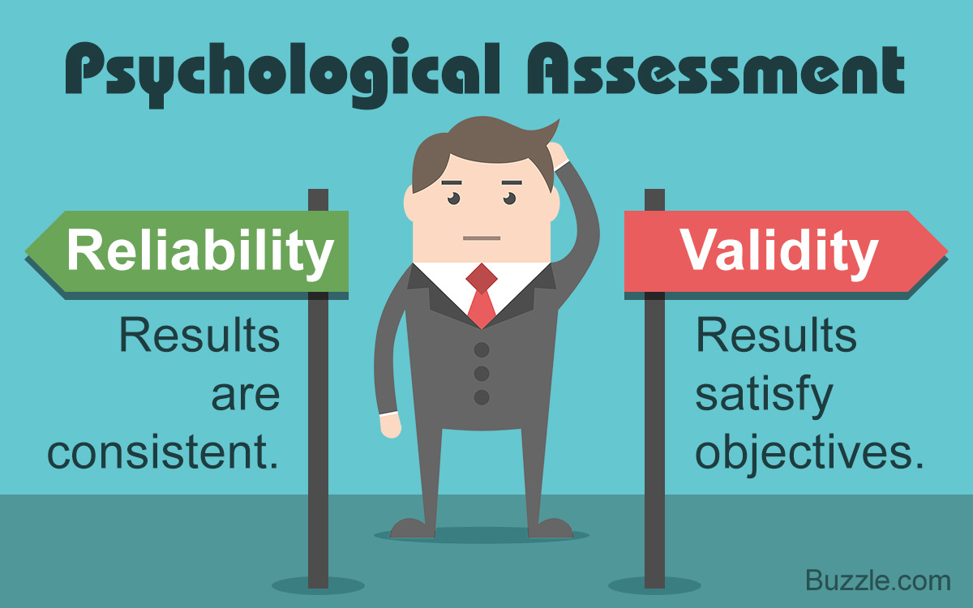
Considerations for Assessment
Having developed the theme of the importance of fair and robust assessments, there is one other main role introduced by the NMC (2018) in the Standards for Student Supervision and Assessment. This is of the Academic Assessor which is mainly a link role between the Practice Assessor and the university. Part of the NMC’s new vision was to embed this role to facilitate better communication and collaboration between the individual clinical areas and the university. Therefore, going forward the Practice Assessor and Academic Assessor will liaise when it comes to making key decisions about student progression.

A named Academic Assessor is attached to each student, rather than the practice area. The student will meet with their Academic Assessor at some point before the placement begins and their name will be recorded in the student’s Practice Assessment Document or MYEPAD, so the identity of the Academic Assessor should be known to the Practice Assessor. The Academic Assessor will support a student through both placements in any one year, but must not cover consecutive years. Therefore, the list of Academic Assessor for any one cohort will be changed each year.

Managing Students Who Are Struggling on Placement:

As soon as a member of the clinical team raises concerns about a student’s performance on placement, the Practice Assessor should be informed, as ideally it is their decision how the situation is managed. Sometimes it may be agreed all that is required is a firm word; in other situations, the team may feel an action plan is required. An action plan is regarded as a formal tool to help a student to focus and develop areas of their practice that are believed to be below the standard expected by the NMC.

An action plan is a document that outlines one or more goals that a student needs to attain. It must also indicate the steps or evidence required to achieve the goals. Most action plans have review dates: some goals are longer term and will take many weeks to adequately demonstrate e.g. ‘improving professional communication skills’. Other goals can be quite short term and achieved very quickly e.g. ‘adheres to uniform policy’ may just require a student to attach their epaulettes, or remove a piercing.

Components of an effective action plan will:

- List clear, well-defined, relevant SMART goals
- Define the tasks, steps or evidence that demonstrates progress and measure achievement
- Stipulate key staff who are involved
- Identify any other resources that are required for success
- Indicate review dates, milestone dates and/or final deadline

Revision of SMART Goals:

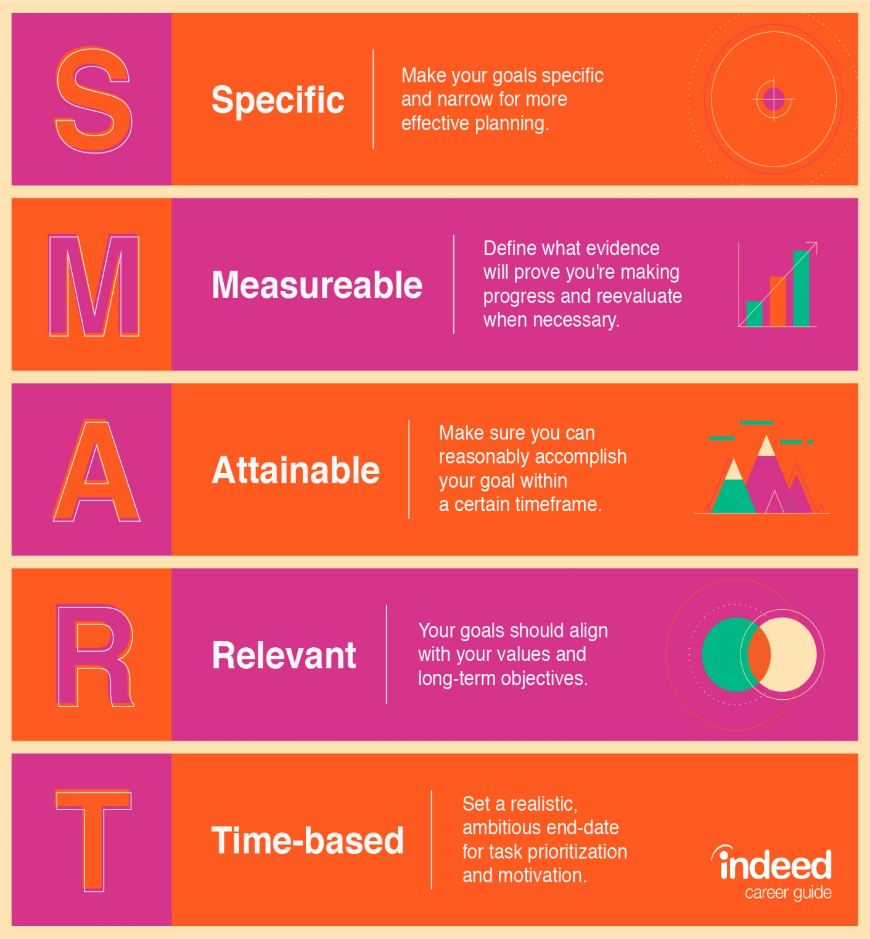

Common Issues That Might Require an Action Plan:

- Poor Attitude
- Poor Motivation
- Poor Attendance
- Poor knowledge
- Poor Communication Skills
- Poor Clinical Skills
- Poor Professionalism
- Poor Understanding of Working Within Limits
An action plan is a useful developmental tool because it gives the learner:

- A clear direction about what is required to pass the placement
- An explicit steer on the clinical opportunities they should seek out
- A specific set of priorities regarding which areas of practice (clinical or professional) they need to obtain feedback on
- A focus to stay motivated and committed
- An important tool to monitor and track their own progress
- A sense of involvement and control, as the action plan should have been written and agreed in collaboration with the student

A template for an action plan is included in the MYEPAD and this can be used as required. Some organisations have their own version, and it is fine to use your preferred action plan template and attach it into the MYEPAD.

Examples of Different Action Plan Templates:

Template 1: a 2nd year student nurse with poor attendance and punctuality

Actions required to achieve: | Support/Resources | Success criteria/achieve by date
Part 2: Professional value No. 15  Jo will be professional, adhering to the NMC Code at all times, being punctual & attending shifts according to the off-duty. Jo will notify the clinical area if sick or unable to attend her rostered shift as per Trust policy. | - PA feedback  - PS feedback  - NMC Code  - Off duty rota  - Sickness/absence reporting email | PA/PS can confirm that Jo:  - acts in a professional manner re: her off duty  - is always punctual for her allocated shift  - adheres to the sickness reporting policy if unwell  Review date: end of placement

Activity 20:

Reflect on action plan template number 1.
Do you like this format ? Would you be able to use it and write similar goals?

Template 2 – a 3rd year student with poor personal values

Concern | Expected Outcome | Action Required
Sam demonstrated poor communication skills to a patient he was caring for.  Professional Values:  2, 3 & 4 | Sam will:  Act in a manner that is attentive, kind sensitive, compassionate and non-discriminating  Demonstrate values that respect diversity & the rights patients have to make their own choices  Seeks confirmation that he understands what the patients have told him  Correctly communicate the needs & wishes of a patient to nursing staff & other professionals  Review progress in:  - week 6  - week 8  - at final interview | In respect of the people Sam is caring for he will  demonstrate the ability to actively listen by:  Using appropriate body language.  Seeking clarification & confirmation that he has understood people, by using paraphrasing, reflection & appropriate questioning skills.  Respond appropriately to any patient queries offering informed & considered opinions & seeks help/advice when required.  Clearly communicates patient needs & wishes to other members of the team.  Delivers care in line with the patient’s wishes.  Being able to identify the signs a person may demonstrate if they do not feel heard or respected.

Activity 21:

Reflect on action plan template number 2.
Do you like this format ? Would you be able to use it and write similar goals?

Template 3 – 1st year student who failed a medicines assessment

Placement Name: |  | Date Action Plan Initiated:
Nature of Concern | What Does the Student Need to Demonstrate? | Support Available and Who is Responsible | Date for Review

Activity 22:

Reflect on action plan template number 3.

Imagine you have assessed a 1st year student on a medicine management assessment. You had to fail them as they did not check the patient’s ID properly and did not specifically gain consent to give a sub-cutaneous injection.

Using template 3, devise two relevant goals and complete all the columns to illustrate how this completed action plan could look.

Accountability When Assessing Students:
All qualified health care professionals should already have a very good understanding of accountability, in terms of how it guides their practice on a day-to-day basis. When you are fully trained to be a Practice Assessor you must also reflect on how accountability specifically affects you when assessing students.
Practice Assessors are accountable in specific ways. They must:

- Have good knowledge and understanding of their accountability
at every stage of a student’s training
- Be accountable to their professional body for the decisions they make regarding pass/fail when assessing student proficiencies
- Demonstrate professional growth, personal development and accountability through their support of students
- Demonstrate a breadth of awareness of assessment strategies
and the ability to contribute to the team’s total assessment process
- Ensure they communicate and collaborate with colleagues in the clinical environment and relevant Academic Assessor
- Ensure they meet with students at the agreed times i.e. mid-point interview, final interview, agreed slots for direct observations and any additional meeting that may be required e.g. to action plan an issue
- Provide constructive feedback to students to assist them to identify and attain future learning needs
- Manage failing students according to Trust/HEI processes. This must be focused on helping students to understand why they have failed and the possible consequences; and to enable them to enhance their performance to achieve safe and effective practice
- Be accountable for confirming that a student has met/has not met the requirements of the professional body in relation to their standards, competencies and proficiencies
- Maintain contemporaneous and factual student records. This involves checking all documentation is:

- Legible
- Signed
- Dated
- Photocopiable
- Accurate
- Openly accessible to the student it is about
- Understandable to the student
- Appropriate/suitable to be counted as ‘objective evidence’
- Complete – all ‘concerns’ are documented and the action to rectify these is also documented
- Able to provide clear evidence for the decisions made

As the new standards have divided the supervision and assessment roles, this means different practitioners facilitate the student’s learning journey on each placement. In this context, each qualified person holds their own accountability for the portion of student learning they are responsible for.
However, the Practice Assessor is ultimately accountable for the pass/fail decision, hence it is within their remit to indicate to the Practice Supervisors, (or the student if applicable), if they believe the Practice Assessment Document or MYEPAD is not meeting the required standard to assist with a fair and objective assessment decision.
It is no longer enough to just complete the basic documentation, as the Practice Assessor now additionally relies on the Practice Supervisors to be keeping brief notes about the student’s progress; this can include comments, positive or ‘negative’, about their knowledge relevant to the placement, their competency relating to clinical skills, their professional values towards patients, relatives and colleagues, and their attitudes in the workplace.

Activity 23:
One of the accountabilities listed above was:
“Be accountable to their professional body for the decisions they make regarding pass/fail when assessing student proficiencies”
Embedded in this point is the most important purposes of accountability. A clue would be to consider the consequences to patients of allowing an incompetent student to progress and qualify: What do you think it is?

Conclusion:
This section started by highlighting that the NMC want Practice Assessors to be clear about their roles and responsibilities, but also where the boundaries exist between their activities and those of the Practice Supervisor and Academic Assessor. A new concept of evidence- based assessment has been introduced, so all assessment decisions must be grounded on what has been objectively recorded about a student. Whilst the Practice Assessor can organise some direct observations of the student to witness their level of skill first-hand, these will not be enough on their own to make a final decision. The Practice Assessor and Practice Supervisors must work as a well-co-ordinated team to generate sufficient evidence about the student’s progress to make a decision that is collaborative, objective, consistent and fair.
Consideration then moved on to focus on some of the key principles of effective assessment. This re-capped on the importance of ensuring students are exposed to different types of assessment, on a regular basis. You were also asked to explore some of the factors that may inadvertently influence our assessment decisions, as it is always vital to be aware of these factors to eradicate (or minimise) personal bias.
There has always been a strong direction from the NMC to ensure those assessing students understand the concepts of reliability and validity, so these have been explored in various ways to highlight why they are so important.
Action planning was explored in some detail, as it is the main tool we use to support students who are struggling on placement, to give them guidance and the best opportunity of a successful outcome.
Finally, we re-visited accountability. In this context it was looked at in terms of how it specially applied to assessing and supporting students.

Activity 24:
As a final activity please watch this Webinar, produced by the NMC. It is currently sitting on a YouTube platform – it is entitled ‘The Role of the Practice and Academic Assessor’. It can be found at the following location:
https://www.youtube.com/watch?v=N3InOolvGUw
It is strongly suggested you take additional notes to supplement the key points covered in this workbook
The presentation slides that accompany the Webinar are in Appendix 2.

References:

- Aliakbari, F; Parvin, N; Heidari, M; Haghani, F. (2015). Learning Theories Application in Nursing Education. Journal of Education and Health Promotion. Published on-line: 23/02/15doi: 10.4103/2277- 9531.151867.
- Black, S; Curzio, J; Terry, L. (2014) Failing a Student Nurse: A New Horizon of Moral Courage. Nursing Ethics. Vol. 21, no 2, 224-238.
- Fahy, A; McNamara, M; Butler, M. (2011) Evaluating Clinical Competence Assessment. Nursing Standard. 25 (50) 42-48.
- Gidman, J; McIntosh, A; Melling, K; Smith. D. (2011) Student Perceptions of Support in Practice. Nurse Education in Practice 11, 351- 355.
- Health Education England, Reducing Pre-Registration Attrition and Improving Retention Report (RePair) (2017) at: https://healtheducationengland.sharepoint.com/Comms/Digital/Shared
%20Documents/Forms/AllItems.aspx?id=%2FComms%2FDigital%2FSh ared%20Documents%2Fhee%2Enhs%2Euk%20documents%2FWebsite
%20files%2FRePAIR%202018%2FRePAIR%20Report%202018%5FFIN
AL%2Epdf&parent=%2FComms%2FDigital%2FShared%20Documents
%2Fhee%2Enhs%2Euk%20documents%2FWebsite%20files%2FRePAIR
%202018&p=true&cid=fb3629c6-3c46-40b6-9957-3daa3ce3adc7
- Health Education, England, (2020). The Impact of Covid 19 on Students Survey (Repair) at: https://healtheducationengland.sharepoint.com/Comms/Digital/Shared Documents/Forms/AllItems.aspx?id=%2FComms%2FDigital%2FShared Documents%2Fhee%2Enhs%2Euk documents%2FWebsite files%2FCovid-19 N%26M%2FReports%2FHEE_Covid_Report_Infographic%2Epdf&parent=%2FComms%2FDigital%2FShared Documents%2Fhee%2Enhs%2Euk documents%2FWebsite files%2FCovid-19 N%26M%2FReports&p=true
- Heaslip, V; & Scammell, J. (2012) Failing the Underperforming Students: The Role of Grading in Practice. Nurse Education in Practice 12, 95-100.
- Hodges, B. (2009). Factors That Can Influence Mentorship Relationships. Paediatric Nursing 21 (6) 32.
- Honey, P; Mumford, A. (1982) Manual of Learning Styles. London, P.Honey
- Kelton, M (2014). Clinical Coaching – An Innovative Role to Improve Marginal Nursing Students in Clinical Practice. Nurse Education in Practice 14, 709-713.
- Kilgallon, K; & Thompson, J. (2012) Mentoring in Nursing and Healthcare: A Practical Approach. Chichester: Wiley-Blackwell.
- Levett-Jones, T; & Lathlean, J. (2009) Don’t Rock the Boat: Nursing Students Experience of Conformity and Compliance. Nurse Education Today. 29, 342-9.
- Levett-Jones, T; Lathlean, J; McMillan, M; & Higgins, I. (2007). Belongingness: A Montage of Nursing Students’ Stories of Their Clinical Placement Experiences. Contemporary Nurse 24, 164-174.
- Nursing and Midwifery Council (2018) The Code. https://www.nmc.org.uk/standards/code/
- Nursing and Midwifery Council (2018). Standards of Student Supervision and Assessment at: www.nmc.org.uk/standards-for-education
- Scrivener R; Hand, T; & Hooper, R. (2011) Principles of Nursing Practice B: accountability and responsibility. Nursing Standard. 25, 29, 35-36.
- Starr, J. (2012) Brilliant Coaching: How to be a Brilliant Coach in Your Workplace, 2nd Ed. Pearson Education Limited, London.
- Van Nieuwerburgh, C. (2016) Coaching in Professional Contexts. Sage Publications Limited, London.
- Walsh, D. (2014) The Nurse Mentor’s Handbook, 2nd Ed. Maindenhead: Open University Press.
- What Helps, What Hinders? Undergraduate Nursing Students’ Perceptions of Clinical Placements Based on a Thematic Synthesis of Literature - Robyn Cant, Colleen Ryan, Lynda Hughes, Elise Luders, Simon Cooper, 2021 (sagepub.com)
- Whitmore, J. (2017) Coaching for Performance: The Principles and Practices of Coaching and Leadership. Nicholas Brealey Publishing, London.

Appendix 1:

Escalating concerns: Practice Education Student flowchart
You identify an issue which gives rise to concern
You are in practice
You are on campus
You feel able to raise your
concerns within the organisation
You feel unable to raise your
concerns within the organisation
Raise your concerns with your:

- Course Director
- Personal tutor
Preferably within 24 hours of the incident verbally or in writing
Raise the concern with:

- The person concerned or
- Your practice supervisor / educator or
- The manager
- Placement co-ordinator / Practice Facilitator
Personal Tutor / Course Director
follows the University ‘Escalating Concerns (Whistle
Blowing) for Students undertaking
Practice Education’
Preferably within 24 hours
of the incident verbally or in writing
The issue is addressed and
managed through the organisation’s ‘Escalating Concerns and Whistleblowing’ policy
The Associate Dean Quality and
Accreditation (or their delegate) contacts the reports the incident to the organisation
involved for investigation




Appendix 2

Slide 1 | Standards for student supervision and assessment:  Role of the assessors  Sue West  Senior Nursing Education Adviser  Rachel Mawby,  Senior Policy Officer (Education)  7 February 2019
Slide 2 | Education programme   Future Nurse Nursing  Standards for standards/ associates Standards for  education Proficiencies standards/ Prescribing  proficiencies  Future  midwife Return to  standards/ practice proficiencies  Quality assurance framework  Communications and engagement

Slide 3
Slide 4 |  |   Standards for student supervision and assessment  Three headings  - Effective practice learning  - Supervision of students  - Assessment of students and confirmation of proficiency
Slide 5 |  | Practice supervision  - In practice, students are supervised by an NMC registered nurse or midwife, or other registered health and social care professionals  - Practice supervision ensures safe and effective learning experiences  - There is sufficient coordination and continuity of support and supervision of students
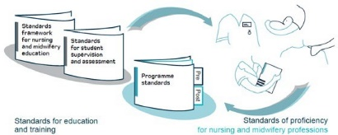

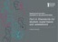
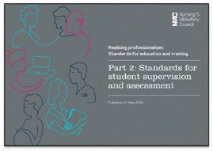

Slide 6 |  | Assessor roles  All students are assigned to:  - a practice assessor for a practice placement or a series of practice placements  - an academic assessor for each part of the education programme  The assessors are:  - registered nurses, midwives and nursing associates with appropriate equivalent experience for the student’s area of practice
Slide 7 |  | Practice assessors  - Conduct assessments to confirm that the student has achieved the proficiencies and outcomes  - assessment decisions are informed by feedback from practice supervisors  - Work in partnership with the academic assessor regarding student progression  - periodically observe the student across environments to inform decisions  - have an understanding of student’s learning and achievement in theory
Slide 8 |  | Academic assessors  - Collate and confirm student achievement of proficiencies and programme outcomes in the academic environment for each part of the programme  - Work in partnership with the practice assessor regarding student progression  - Communication and collaboration is scheduled for relevant points in the programme

Slide 9 |  | 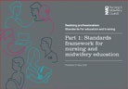  Student  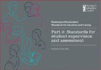  Practice Academic  assessor assessor  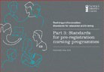
Slide 10 |  | Supporting information for supervision and assessment  Split into five sections  - Practice supervision  - Practice assessment  - Academic assessment  - Learning environments and experiences  - Student empowerment
Slide 11 |  | Considerations  - Need for effective partnerships between AEIs and practice learning partners  - Introduction of new roles  - What supervision and assessment model will work in practice learning environments  - Who will be supervisors and assessors  - How will they be prepared for their role  - Impact of the new standards on all registrants  - Awareness of the new roles for supervision and assessment  - Awareness and review of the standards of proficiency in keeping with your/their scope of practice  - Planning your/their CPD accordingly in preparation for revalidation

Slide 12 | https://www.nmc.org.uk/supporting-information-on- standards-for-student-supervision-and-assessment/  Thank you  What questions do you have?  Please send through to: Educationandstandards@nmc-uk.org

