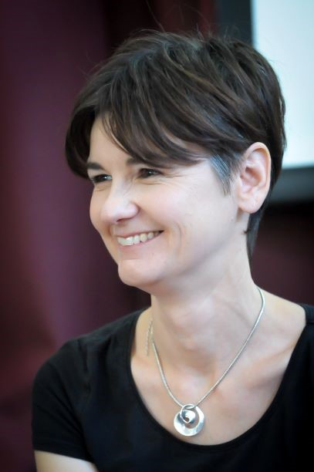
Dr Sarah Raistrick

Trailblazer Fellow – NHSE WTE
C&W Cohort 4 2023/24

Willenhall Primary Care Centre, Coventry

I am a GP of almost 20 years, and after training and practicing in London I have been working in Willenhall, Coventry for the past 9.

I have an interest in System, Community and partnership working to improve health equity. I also acknowledge the messy complexity of people’s lives. Currently I am the Coventry Marmot Partnership Chair and hold several NHS Non-Exec roles.

