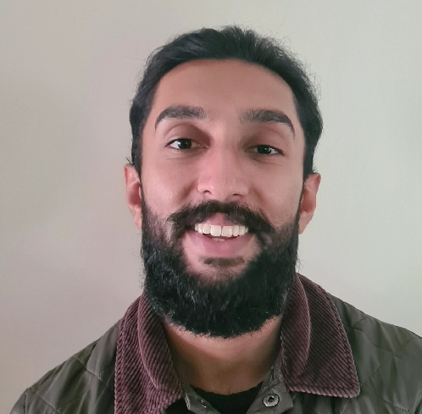
Dr Dilraaj Nijjar

Trailblazer Fellow – NHSE WTE
C&W Cohort 4 2023/24

Kenyon Medical Centre, Coventry

Hi, I am Dil!

I’m a newly qualified GP having completed my medical training across Coventry and Warwickshire. I am familiar with the area and services. I want to use my fellowship year to focus on improving diabetes care across my practice and PCN.

I am looking to engage at different community and secondary care levels to gain knowledge, improve services and optimise patient care.

