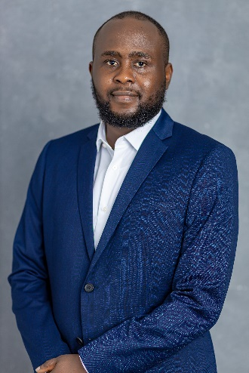
Dr Chikeluba Okoli

Trailblazer Fellow (NHS WTE)
C&W Cohort 4 2023/24

Woodend Health Centre, Coventry

I am a newly qualified GP Currently at Woodend Health Center in Coventry. I have previously worked in Emergency department and Urgent Treatment Center in London before joining the Coventry VTS for training.

I did my ST3 at Woodend Health Center where I became aware of some of the challenges of delivering healthcare in a deprived population as such the opportunity to arm myself with the skills and knowledge to be effective in my service delivery was one I was in trusted in taking up.

Hopefully at the end of the fellowship I would have grown as a healthcare professional as well as develop and execute projects that will improve the health outcomes of the patients in my local community. I also aim to develop a rich network as I gain experience and understanding on how to effectively manage patients in the deprived areas.

