Roadmap Documents
Historical background and context
• First Contact Practitioners (FCPs) roles began with the development of the FCP Physiotherapist in 2014, in response to the shortage of General Practitioners (GPs) in general practice. FCP roles were designed to support GP practices as part of an integrated care team and to optimise the patient care pathway by seeing the right person in the right place at the right time - https://gettingitrightfirsttime.co.uk/.
• As the FCP role, the FCP Physiotherapist role created a template for other professions to use and develop FCP roles in general practice. This created an assurance that there was a standardisation of quality provided across multiple professions who were delivering in a general practice setting. This standardisation assures governance and ultimately patient safety, ensuring capability to see and manage undifferentiated and undiagnosed MSK presentations within an agreed scope of practice.
Following the success of the FCP Physiotherapists and the implementation of this approach to other professions we have seen an increase in First Contact Practitioners who together make up a large and ever-increasing amount of the general practice workforce. We now see a wide range of professions described as FCPs including physiotherapists, occupational therapists, dieticians, podiatrists, physician associates, paramedics, mental health practitioners and clinical pharmacists (plus a wide range of non-clinical roles) working in general practice following the introduction and accompanying funding from the General practice Network Directed Enhanced Service (PCN DES). This new workforce team is often referred to as ARRS as a result of the scheme that funds them being called Additional Roles Reimbursement Scheme
• To create sustainability for multi-professional FCP roles, there is a need to build a clear national general practice training pathway for clinicians moving into FCP roles onto Advanced Practitioner, which ultimately will provide a pipeline of professionals working at the right level of practice, and will help to recruit and retain this workforce; support the managing of increased demand and complexity being seen in general practice and improve patient outcomes and the patient experience.
• HEE general practice training begins at a minimum of three years post clinical registration (see diagram below) within the clinical area they will be practicing.
For clarity HEE refer to general practice as Primary Care (PC) - whilst the correct terminology is general practice there are references to PC in the information shared later in this document.

We also acknowledge that is great confusion between First Contact Practitioner which covers a range of professions versus First Contact Physiotherapists which is the term used in the PCN DES to cover the ARRS physios. We also recognise neither the GP practice workforce nor patients recognise or understand the term First Contact Practitioner however again for purposes of this paper this term is used to describe the following roles (split into those with and without roadmaps): -
Roles with Roadmaps
Physiotherapists
First Contact Practitioners and Advanced Practitioners in Primary Care: (Musculoskeletal) A Roadmap to Practice First Contact Practitioners and Advanced Practitioners in Primary Care: (Musculoskeletal) A Roadmap to Practice (hee.nhs.uk)
Occupational Therapists
First Contact Practitioners and Advanced Practitioners in Primary Care: (Occupational Therapy) A Roadmap to Practice First Contact Practitioners and Advanced Practitioners in Primary Care: (Musculoskeletal) A Roadmap to Practice (hee.nhs.uk)
Paramedics
First Contact Practitioners and Advanced Practitioners in Primary Care: (Paramedics) (hee.nhs.uk)
Dieticians
First Contact Practitioners and Advanced Practitioners in Primary Care: (Dietitian) A Roadmap to PracticeFirst Contact Practitioners and Advanced Practitioners in Primary Care: (Musculoskeletal) A Roadmap to Practice (hee.nhs.uk)
Podiatrists
First Contact Practitioners and Advanced Practitioners in Primary Care: (Podiatry) A Roadmap to PracticeFirst Contact Practitioners and Advanced Practitioners in Primary Care: (Musculoskeletal) A Roadmap to Practice (hee.nhs.uk)
Roles currently without Roadmaps
Physicians Associates
June 2022 MAP Core Capabilities Framework FINAL.pdf (hee.nhs.uk)
Care Co-Ordinators
Health and Wellbeing Coaches
Social Prescribing Link Workers
Clinical Pharmacists
the-rps-roadmap-to-advanced-practice.pdf (rpharms.com)
Mental Health Practitioners
Nursing Associates.
Speech and Language Therapists

Roadmap Process
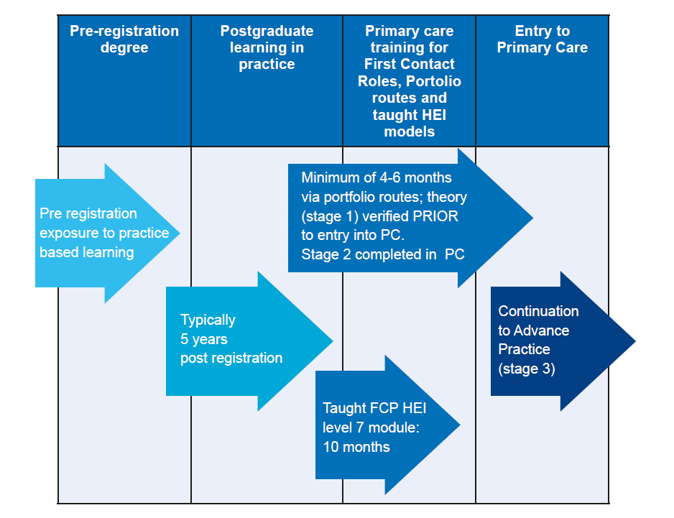
Clinicians proceeding through the FCP Roadmap will need to be supported by a verified roadmap supervisor to complete required general practice recognition (Stage 1 on the HEE Road Map) this can be started and completed prior to entry into an FCP role and completed either in practice or through HEI modules. For paramedics roadmap supervision is likely to be delivered by the ambulance trust though this may differs depending upon the geographical area (I.e., West Midlands Ambulance Trust do not offer this service). Some paramedics may already be working in general practice at academic level 6, to ensure standardisation of the role and effective governance, paramedics may complete and evidence their clinical practice using a portfolio to achieve stage 1 and 2 of the portfolio with support of their road map supervisor (Please note the timeline for stage 1 can be amended by the local commissioner i.e., take 12 months as opposed to 6 months).
WHAT IS AN FCP?
A First Contact Practitioner (FCP) is a diagnostic clinician working in General practice at the top of their clinical scope of practice at master’s level, Agenda for Change Band 7 or equivalent and above. This allows the FCP to be able to assess and manage undifferentiated and undiagnosed presentations.
✔ It is the minimum threshold for working as a first point of contact with undifferentiated undiagnosed conditions in general practice. With additional training, FCPs can build towards advanced practice (see figure below).
✔ The clinician must have a minimum of three years of postgraduate experience in their professional specialty area of practice before starting general practice training to become an FCP.
✔ To become an FCP, recognition is required through Health Education England, whereby a clinician must have completed a taught or portfolio route.
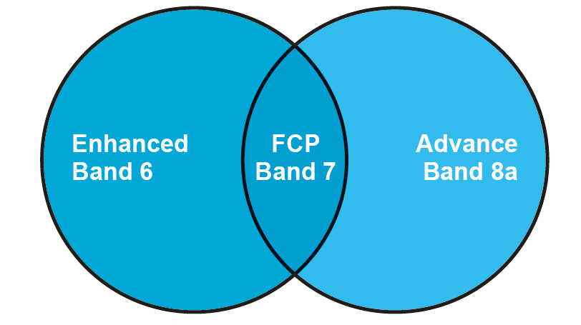
What is an Advanced Practitioner?
• An Advanced Practitioner (AP) is a clinician working at an advanced level across all four pillars of advanced practice at master’s level.
• The four pillars include research, leadership and management, education, and clinical practice.
• AP works at Agenda for Change band 8a or equivalent and above.
• An AP in General practice can develop from a range of specialties, if their evidence (either through an HEI or portfolio route) is mapped against the relevant capabilities/frameworks and level 7 educational standards
Under the current PCN DES each PCN is funded for 3 APS only (as of 2023) (this does not mean they cannot recruit, employ more it means they are only able to claim funding up to the maximum reimbursable amount as per the PCN DES for 3 APs)
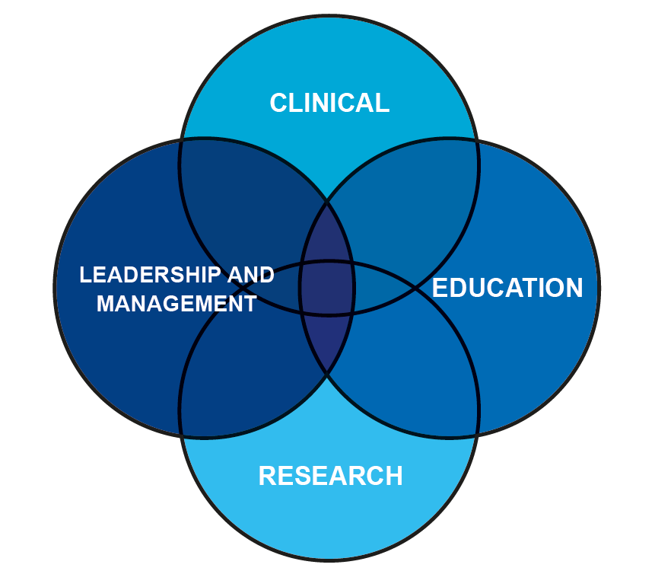
How do we remunerate clinicians based on their evidence of capability?
• Remuneration should be based on a clinician’s evidenced capability and application of skills in practice.
• General practice does not traditionally use Agenda for Change (AfC) pay bands to determine rate of pay but AfC is useful as a guide to a minimum rate of pay in relation to a clinician’s level of practice. Note: ARRS salaries and changes to the remuneration for ARRS roles in dictated by the DES contract, any change is at the discretion of the PCN.
• Agenda for Change ‘Bands’ are NHS pay bands that are applicable to all professionals with the exception of doctors, dentists and some very senior managers in the NHS. Pay scales for 2022/23 | NHS Employers
• The table below shows the difference in capabilities between an FCP (master’s level in the clinical pillar, pay band 7) and an AP (master’s level across all four pillars, pay band 8a) and the added breadth of practice that an AP demonstrates.
• An AP demonstrates all the capabilities listed for FCP plus the additional capabilities listed for AP.
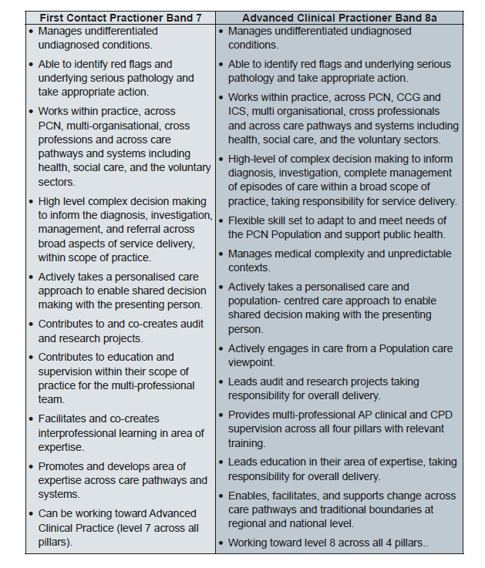
The Centre for Advancing Practice
The Health Education England Centre for Advancing Practice (The Centre) has been established, working extensively and collaboratively with professional bodies and other stakeholders, to support education and training for FCPs and APs in England. FCP roles will be supported by The Centre in the following ways:
• A retrospective route for existing FCPs will be available via the portfolio route to gain recognition.
• FCP recognition is not a ‘short cut’ to full AP status and not all FCPs will chose to progress to AP. However, any evidence collected in the FCP portfolio relevant to the AP portfolio can be used for further submission, in combination with the additional evidence required for AP status.
• The Knowledge, Skills, and Attributes (KSA) document describes the prerequisite knowledge, skills, and attributes stipulated for clinical professionals moving into Clinician FCP roles within General practice. Mapping against the KSA document with a portfolio of evidence is the recognition requirement for Stage 1, alongside completion of the General practice and personalised care e-learning modules.
• FCP supervisors will be required to have completed an approved General practice two-day training programme, which will allow them to support clinicians in achieving both FCP and AP recognition.
• GP Trainers will be able to access a shortened version of the above course

General practice educational pathways
There are two main educational pathways to practice in General practice, illustrated below:
• FCP portfolio or taught route plus portfolio of evidence within General practice,
• AP portfolio or taught routes plus portfolio with the addition of the required General practice KSA training.
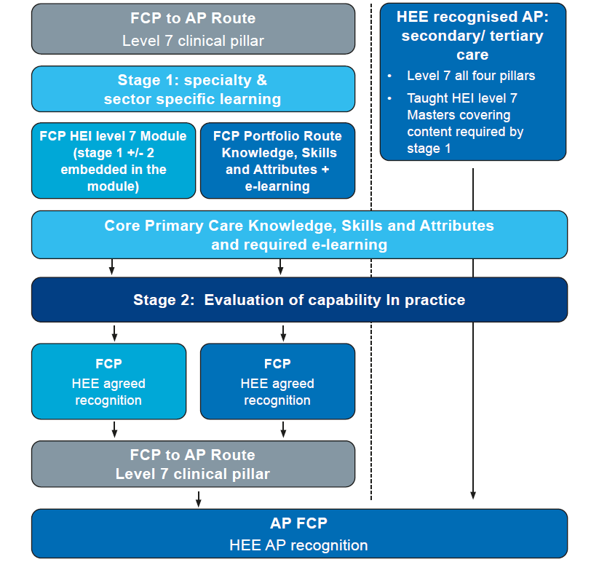
The Roadmap to FCP
The process to train formally to be an FCP can begin at a minimum of three years of post-registration experience. Clinicians at every stage should be up to date with all required statutory and mandatory training in their area of practice.
• Stage 1 must be started with a portfolio of evidence and verified before employment in General practice. (Exemption- paramedics – who should be working towards the equivalent capability in paramedic areas of practice). The KSA must be completed prior to employment as an FCP or AP in General practice to ensure patient safety. For Clinicians already working in General practice, this can be completed retrospectively.
• Stage 2 is completed with a portfolio of evidence and verified in General practice. This is the recognition process of the application of the KSA in Stage 1 to clinical practice in General practice. Best practice is that this should be completed within six months for a full-time member of staff, but this can be longer provided a completion date is agreed with the employer.
If the clinical undertakes the portfolio route, stage 1 and 2 can be completed simultaneous, utilising the supporting evidence to complete the KSA and demonstrate core clinical skills in practice.
• Once Stage 1 and Stage 2 are verified, the practitioner can apply for inclusion on the directory at the Centre for Advancing Practice as an FCP and would be able to continue building evidence towards AP.
• The clinical supervisor who recognises the above stages must be a verified FCP, an Advanced Practitioner, a Consultant Practitioner, or a GP who has completed the HEE two-day General practice supervisor training. This is a specific two-day supervision course to train as an AP roadmap supervisor to support FCP and AP practice in General practice, and to learn how to use the adapted RCGP toolkit for Stage 2 recognition.
• GP trainers will be able to access a shortened version of this course. There are currently two surveys that form an interim process to collect a list of practitioners who have completed FCP recognition to be credentialed, and who will be transferred to the Centre for Advancing Practice. Once the Centre for Advancing Practice is fully operational, the surveys will be transferred towards the directory. General practice Clinical Level 7 - FCP Survey General practice Clinical Level 7 - FCP Supervisor Survey
• A taught level 7 Higher Education Institute (HEI) FCP module will have both stages within the course content and will be verified by the HEI. The clinician completing the taught FCP course will need to complete both surveys until The Centre is operational.
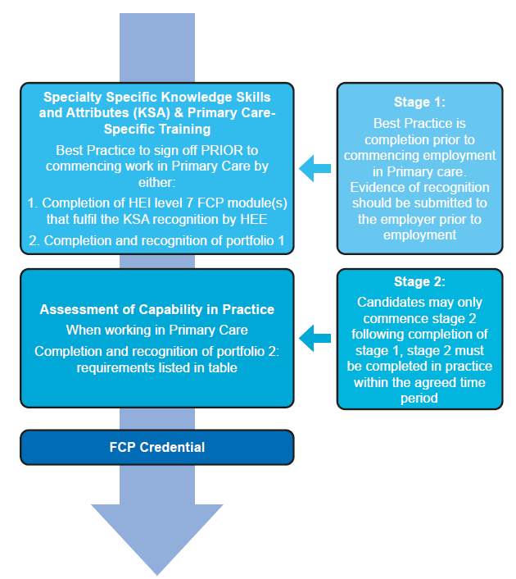

Stage 1 for FCPs: Knowledge, Skills & Attributes (KSA)
E-learning
• The early stages of creating a portfolio of evidence towards FCP start with the completion of several important e-modules. These are free to access for NHS staff and can be accessed by external partners for a small fee.
• The General practice modules cover areas such as managing complexity, mental and public health, illness identification, and red flags and are complemented by a series of e-modules covering personalised care. Clinicians are required to complete all modules associated with both programmes.
• Once the e-learning modules have been completed, the ‘trainee’ FCP must access an appropriately trained AP supervisor (see section 9 for details).
• Once agreed, the supervisor will work with the ‘trainee’ FCP to review their current portfolio of knowledge and assess any learning needs required against the KSA document
Next steps
• The supervisor and ‘trainee’ FCP will create a plan that will be based on their profession and/or speciality, and the FCP Clinician KSA and related frameworks.
• The ‘trainee’ FCP is advised to register with The HEE Centre and utilise the online portal. The Coventry and Warwickshire Training Hub has procured the clarity e-portfolio to help FCP develop their online portfolio. This will allow the ‘trainee’ FCP to upload evidence of transferable capability against this training pathway, which can be applicable across all CPD settings including General practice.
• The ‘trainee’ FCP then begins the process of portfolio of evidence development which map to stage 1 and stage 2 of the FCP roadmap and develop their clinical competencies. Some evidence can be cross-referenced against the relevant frameworks and will allow the ‘trainee’ FCP to build evidence towards competence within General practice (FCP) or AP. Evidence can be from practice, from higher educational institutions (HEIs), or from both as required. Once Stage 1 has been started, the individual can embark into General practice.
• If an individual does not wish to complete a portfolio route to FCP, they could access a HEI FCP level 7 module to evidence relevant study for their role.
• The ‘trainee’ FCP using a HEI route will still be expected to complete the e-learning modules and have their KSA verified, but their general practice recognition may occur within the module itself and may not require any further process.
• Throughout the clinical experiences, it is recommended that evidence is continually uploaded into the FCP Portfolio, enabling the ‘trainee’ FCP to continue logging their learning/career journey towards AP.
• In the other two frameworks this reads as: for the already verified advanced practitioner registered on the Centre for Advancing Practice Directory wishing to also work in General practice, the process still requires the e-learning to be completed and the KSA capabilities verified within General practice.

Stage 2:
Moving into General practice on completion of the KSA recognition (Stage 1),
The ‘trainee’ FCP can continue to build their general practice portfolio in practice (Stage 2) which should demonstrate competence across the KSA. These tasks comprise the core General practice knowledge and skills required. A range of portfolio materials have been derived from tools used by GP Specialty Trainees and adapted with kind permission from the Royal College of General Practitioners (RCGP) (see appendices).
The portfolio and Workplace-Based Assessment (WPBA) materials have been developed to support FCPs, Clinical Supervisors, and other stakeholders to evidence capability. The portfolio tools offer the opportunity to collate a range of triangulated evidence. This includes not only WPBA but also personal reflective log entries, work around audit/ quality improvement, and feedback from patients and the clinical and non-clinical team members. It provides the opportunity and the means for supervisors to review and comment on progress and support learning.
These tools have been used by the RCGP as part of the GP training programme for many years and they provide robust evidence. General practice Schools, general practice, and GPs will be familiar with these WPBA tools helping implementation. FCPs should maintain a portfolio of evidence to demonstrate capability and/or career progression. Each FCP and AP should keep a Learning Log that includes regular case based or professional reflection. Detailed evidence of applied learning or action points arising from reflection should be noted.
Evidence to Include in Portfolio
While specific evidence may be suggested on the advice of the supervisor to support recognition, it is advised that the portfolio for recognition includes the following:
• Personal Development Plan (PDP) identifying SMART objectives (with formal six month and yearly reviews)
• A record of e-modules successfully completed
• A record of HEI modules successfully completed
• A contemporary record of mandatory training, including Basic Life Support and Safeguarding
• Reflective learning logs
The portfolio should also include a record of Workplace-Based Assessments to include a minimum of:
• Consultation Observation Tool (COT) – one per month (Full Time Equivalent (FTE))
• Case-Based Discussion (CBD) – one per month (FTE)
• A range of Clinical Examination Procedural skills (CEPs)
• Quality Improvement Projects/complete audit cycles demonstrating on-going engagement improvement methods and shows systematic change/leaves a legacy
• Patient compliments or complaints
- Significant Event Analysis
- Patient Satisfaction Questionnaires (PSQ) – at least one full round with 40 respondents
- Multi-Source Feedback (MSF) – at least one full round with 10 respondents, five clinical and five non-clinical
Building the portfolio
A portfolio is an individual’s collection of evidence that illustrates development and learning to date and provides an overview of plans for future development. In addition, it facilitates analysis of current skills and knowledge through critical reflection and evaluation of learning and development. It is therefore more than a record of the CPD activity undertaken. Brown (1992) usefully defines a portfolio as: ‘A private collection of evidence which demonstrates the continuing collection of skills, knowledge, attitudes, understanding and achievement. It is both retrospective and prospective, as well as reflecting the current stage of development of the individual.’
STEP 1: COLLATE KEY DOCUMENTS As an example, submission and evaluation of a completed portfolio could take the following form:
- QUALIFICATIONS AND MEMBERSHIP AND (2) CLINICAL EXPERIENCE
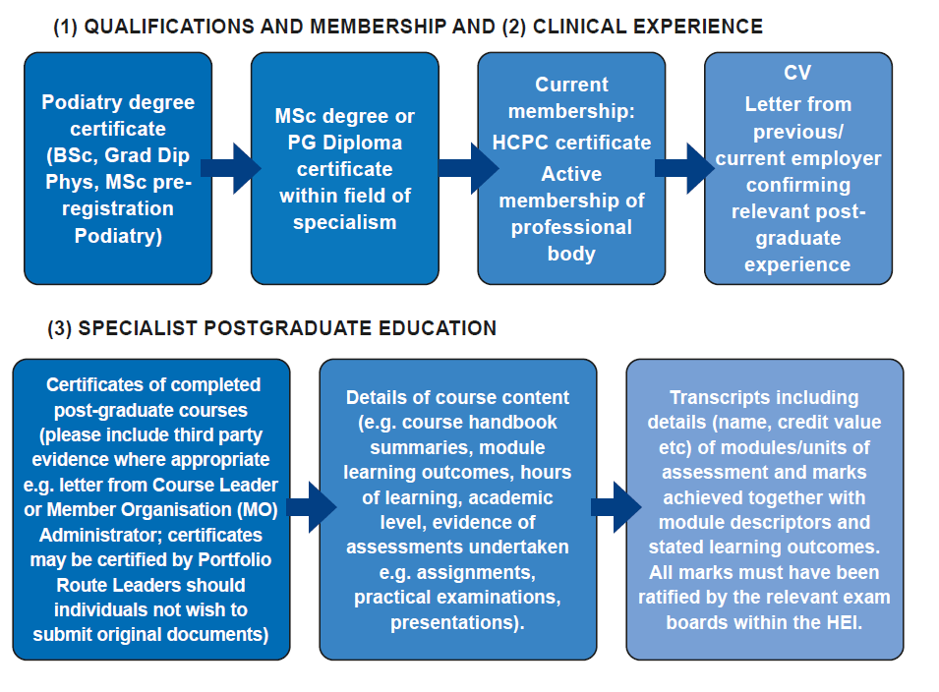

STEP 2: ALIGN AND UPLOAD
Key documents can be uploaded to The Centre portal once attained. The accompanying portfolio document outlines how key documents evidence KSA capability in totality. Trainee FCPs are encouraged to build their portfolio until they and their supervisor are happy that all Knowledge, Skills and Attributes are adequately evidenced at a QAA level 7 standard. Once satisfied that all required key document evidence and portfolio detail are mapped, the portfolio can be submitted to The Centre for verification.

Recognition and supervision process
Recognition process

• The recognition process provides quality assurance and governance of a role against a standard of practice.
• For FCP and AP, this will be assessed at level 7 master’s (M) level (not to be confused with banding).
• It is critical to have a standardised recognition for FCP roles as a minimum entry level for diagnostic clinicians in General practice and AP roles, as clinicians are working with undifferentiated and undiagnosed conditions, often within the context of multi-morbidity and polypharmacy. This requires the FCP to be working at the top of their clinical scope of practice to ensure patient safety and to be effective in their role.
• The capability documents are standardised in all routes to ensure the level and quality of practice, and to provide governance of the roles for the Care Quality Commission and professional registration bodies.

To gain recognition through a portfolio route, an FCP must have:
1. A recognised General practice supervisor
2. Completed the relevant e-learning modules – pre-Stage1
3. Completed a verified portfolio of evidence cross-referenced against the domains of the Knowledge, Skills and Attributes document – Stage 1
4. Completed a portfolio of triangulated evidence of General practice training – Stage 2

Assessment Criteria Level 7

Study at master’s level 7 will have been at, or informed by working at, the forefront of an academic or professional discipline. Clinicians will have shown originality in the application of knowledge, and they will understand how the boundaries of knowledge are advanced through research. They will be able to deal with complex issues both systematically and creatively, and they will show originality in tackling and solving problems (QAA Framework for Higher Education Qualifications, 2001). The table below outlines the grade attributes applied to level 7 assessment.

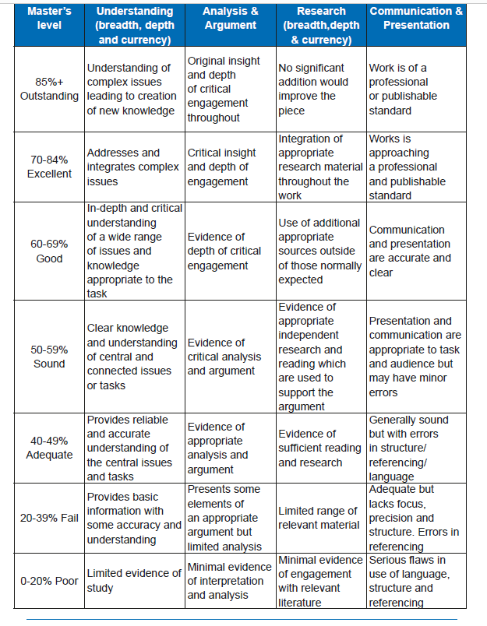

Roadmap supervision and verification

Roadmap Supervision and Verification is a process of developing a portfolio of evidence academically and the application of that knowledge into practice. This is marked and signed off by a recognised Roadmap Supervisor. For the purpose of this document and the FCP to advanced practice training pathway in General practice, two types of supervision have been defined. These forms of supervision happen concurrently but with a different focus.

Educational supervision is also defined as below. Once recognised as an FCP or AP on the directory, relevant regular practice supervision is put into place. Supervision has many definitions across healthcare, with individual professions and regulators often having their own. Definitions can also vary between clinical settings. Supervision is key in developing safe and effective practitioners and promoting patient and practitioner safety. The provision of all supervision is the responsibility of the employer.

Supervisor requirements

To be able to supervise FCP or AP, supervisors must have undertaken the approved HEE ‘Multi-Professional Supervision in General practice for FCP & AP’ course. This course will include:
• The role of clinical supervision and CPD supervision
• An overview of educational theory
• Creating an educational culture
• Feedback
• The journey to FCP or AP roles
• Supporting trainees in/with difficulties
• How to use WPBA
• Supporting FCP or AP with their portfolio of evidence

Stage 3: Roadmap to AP

There are two ways to be verified for AP in General practice as part of FCP to AP career progression:

1. To have completed the e-learning modules, have a portfolio of triangulated evidence cross-referencing against the domains of the Knowledge, Skills and Attributes document, and to have completed the outstanding domains as referenced in the ‘Linking FCP to AP – Top-up required for AP’ document.

2. For the taught AP master’s degree, General practice training will need to be completed if working in General practice along with a portfolio of evidence against the appropriate AP profession specific framework.
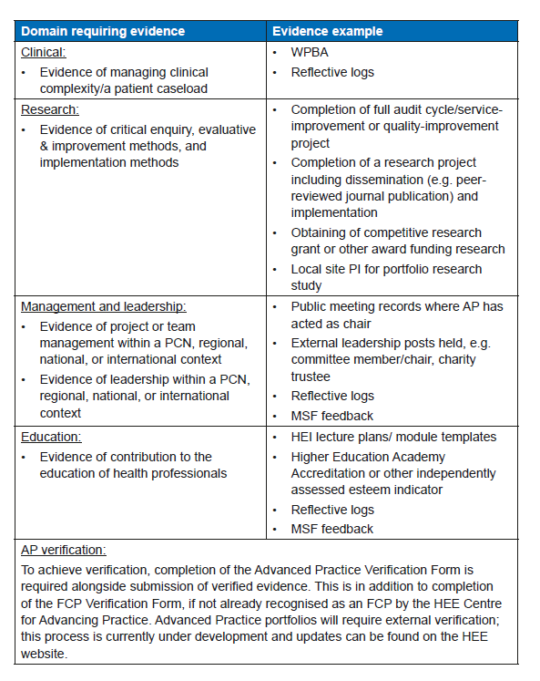

Demonstrating Advanced Practice in a General practice portfolio

• The document ‘Linking FCP to AP – Top-up required for AP’ allows evidence to be built against the KSA (Stage 1) requirements and as the Clinician develops further into General practice (Stage 2) and on to AP (Stage 3).

• Each FCP prerequisite KSA is mapped to the relevant dimensions of the HEE Multi Professional Advanced Practice, fulfilling a subset of the clinical standards required by the Advanced Practice within General practice.

• A completed portfolio can therefore be used to evidence fulfilment of a specific subset of the clinical pillar required for recognition as a Clinician Advanced Practitioner within General practice and can be transferred across to an AP portfolio.

• The Clinician then needs to build their evidence against the three other pillars that are not fulfilled during FCP training (either KSA/ Stage 1 or General practice/Stage 2). To aid this, the document shows both the FCP and AP capabilities/competencies in one document so that it is explicit as to what is required for FCP roles, and what is needed to become an Advanced Practitioner in General practice.

• The required KSA that are essential to FCP, and must be demonstrated as a portfolio of evidence, are detailed within the appendices.

• Following recognition as an FCP, the FCP can continue to collate their evidence against the additional AP capabilities to work towards AP accreditation. This could be completed through an appropriate registered AP pathway, such as a profession-specific special interest group, or directly via the HEE portal as outlined above. FCP’s can evidence the remaining KSA, plus any additional ‘bolt-on Knowledge, Skills and Attributes’ required, prior to submitting their Advanced Practitioner portfolio. These additional requirements are detailed within the appendices.

