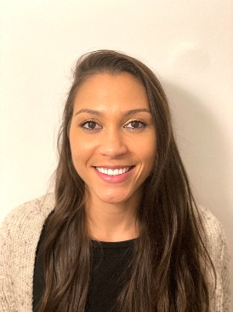
Dr Lizzie Murphy

Aspiring Leaders Cohort 3 2022/23
HEE Trailblazer Fellow – Leaders in Deprivation
Engleton House Surgery, Coventry

I am a newly qualified GP having previously worked in emergency medicine for several years as a senior house officer in various emergency departments across the UK. During my career I realised how much I enjoy the challenge and rewarding nature of working in deprived areas.

I am currently working as a salaried GP at Engleton House Surgery serving an area of deprivation in Coventry. I am excited about the opportunity to be part of the deprivation fellowship programme to contribute towards improving health equity in primary care, to gain a greater understanding of the challenges experienced by the patient population I am serving and further develop my interest in inclusion health.

